**Program 1**

<html >

<head>

<title>My first web page</title>

</head>

<body bgcolor="green">

<font size="16" color="white" face="Arial"> Welcome to AITS, TIRUPATI...</font>

</body>

</html>

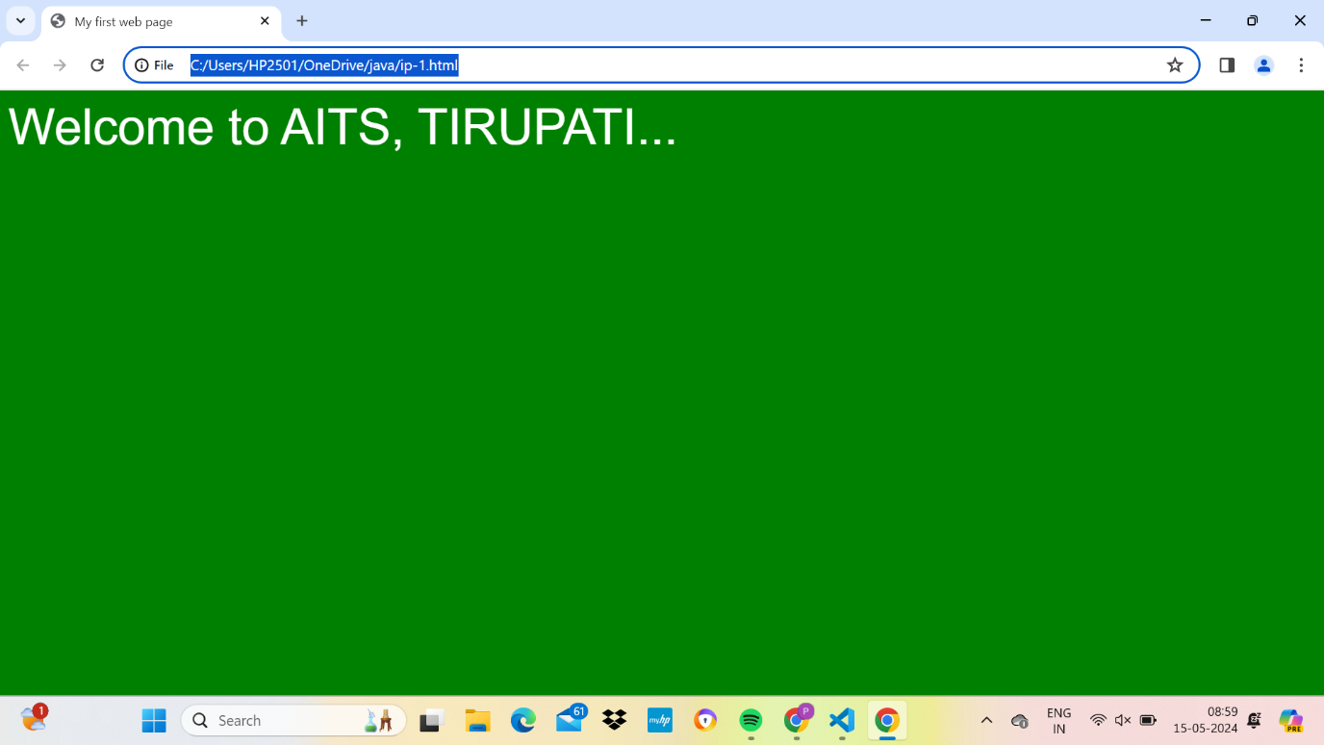

**Program 2**

<html>

<head>

<title>program 02</title>

</head>

<body>

<p align="center">

Name: AITS<br>

Age: 16

</p>

<p align="right">

Address: Aghraharam post TIRUPATI<br> Phone:

123535615

</p>

<p align="left">

Reg No:

20AK1A0501<br>

Class:2nd Sem C’s

</p>

</body>

</html>

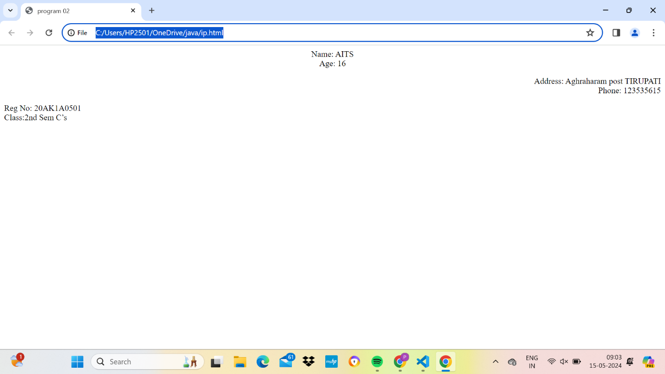

Program 3

<html>

<head>

<title>program 03</title>

</head>

<body>

<center>

<h1>Basic Web design Lab</h1>

</center>

<h2 align="left"> Definition </h2>

<h3 align="left">Website</h3>

<p>

A set of inter connected web pages usually including a home page and many other web pages

</p>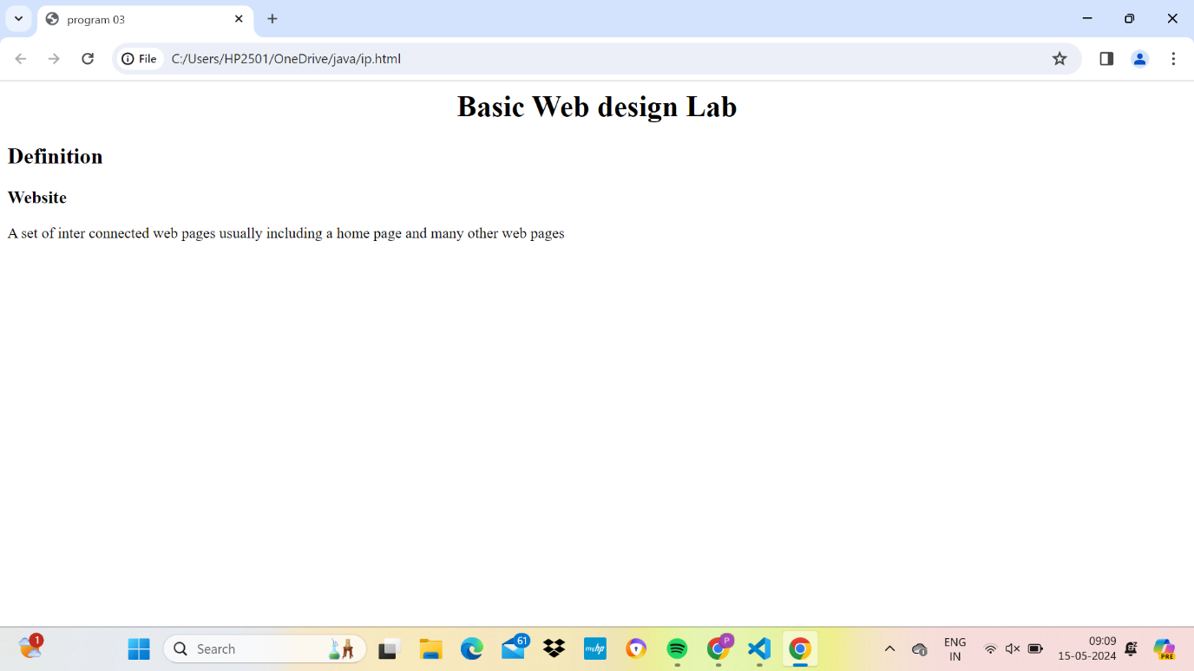

Program 4

<html>

<head>

<title>program 04</title>

</head>

<body>

<p> <b> <i> log</i></b> <sub>b </sub>m<sup> p</sup> =p<b> <i> log </i>

</b><sub>b</sub> m</p>

</body>

</html>

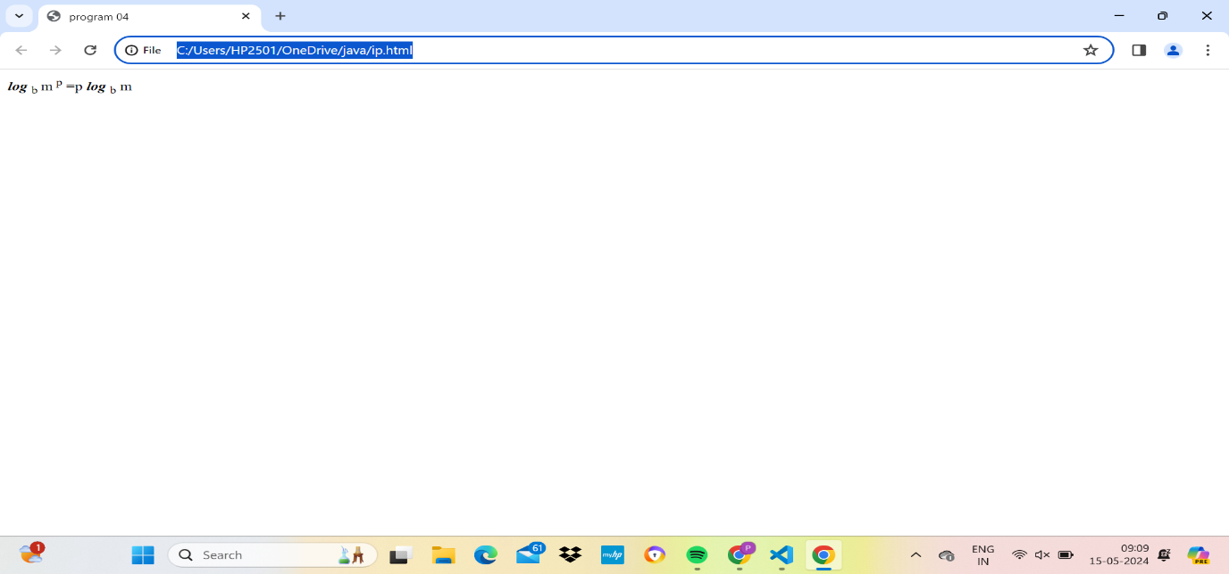

Pr0gram 5

<html>

<head>

<title>program 05</title>

</head>

<body>

<center>

<img src="C:\Documents and Settings\All Users\Documents\My Pictures\Sample

Pictures\Winter.jpg" height="200" width="200" align="middle"/>

</center>

</body>

</html>

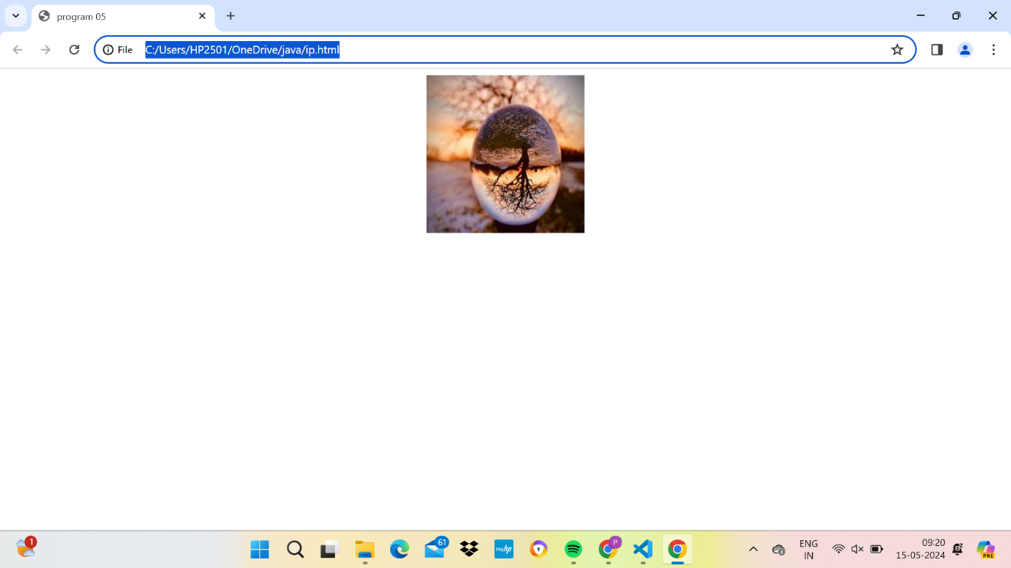

Program 6

<html>

<head>

<title>program 05</title>

</head>

<body>

<a href="p2.html">

<img src="C:\Documents and Settings\All Users\Documents\My Pictures\Sample

Pictures\Winter.jpg" align="left" width="200" height="200"/>

</a>

</body>

</html>

**P2.html**

<html>

<head>

<title>program 06</title>

</head>

<body> Hi Welcome ... </body>

</html>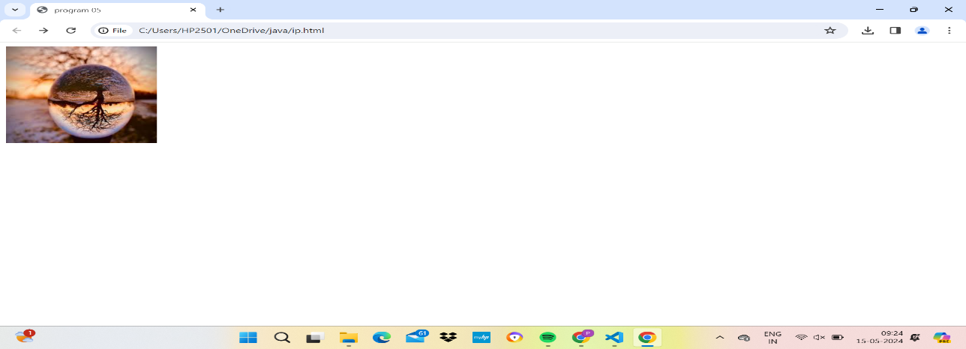

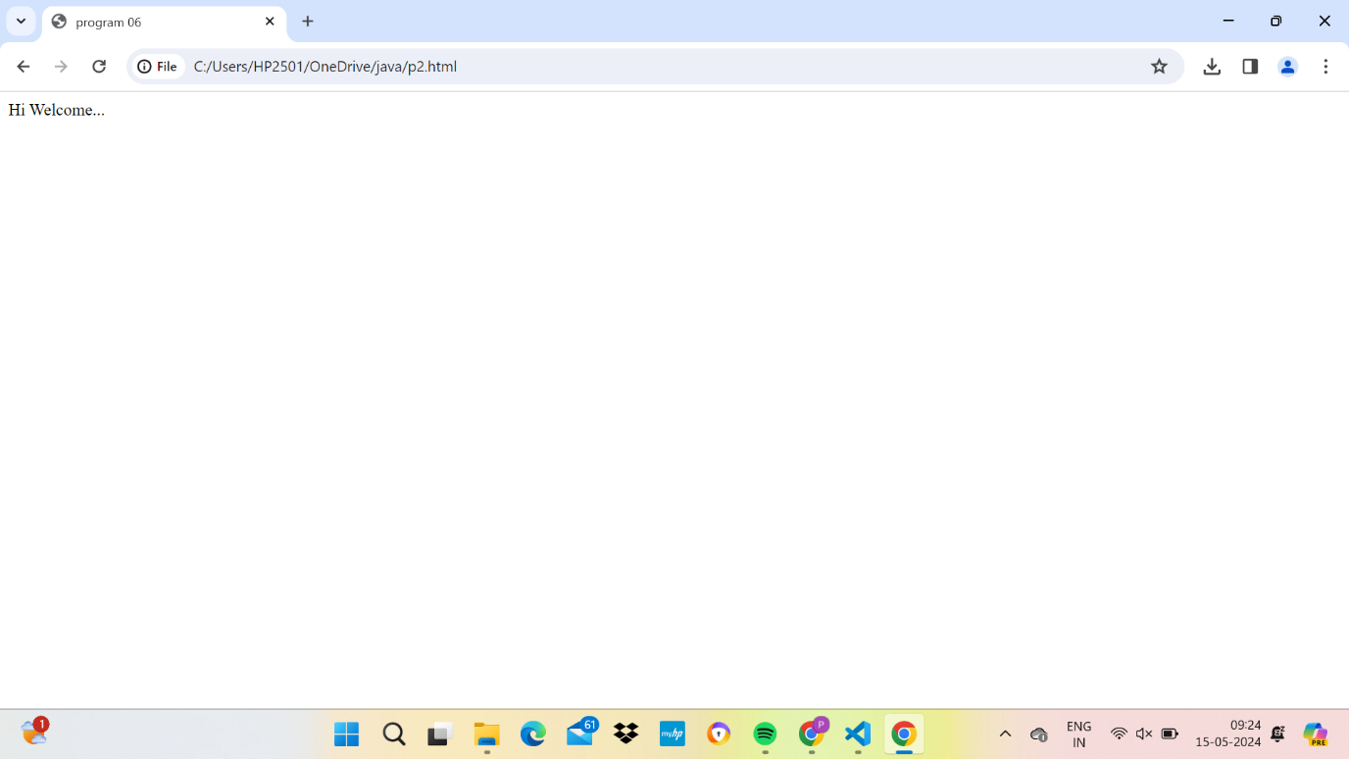

Program7

<html>

<head><title>page 1</title>

</head>

<body>

<p>Welcome to AITS</p>

<a href="http://www.gmail.com">click here to link gmail website</a>

</body>

</html>

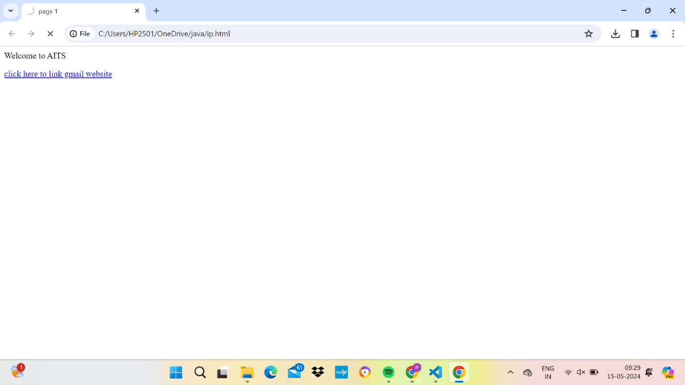

Program 8

<html>

<head><title>program 8</title></head>

<body>

<a name="home"></a>

<p>**include paragraph**

</p>

<h1>contents</h1>

<a href="#link1">History</a><br>

<a href="#link2">Html version</a><br>

<a name="link1"></a>

<p>**include paragraph**

</p><br>

<a name="link2"></a>

html versions

<p>**include paragraph**

</p></br>

<a href="#home">home</a>

</body>

</html>

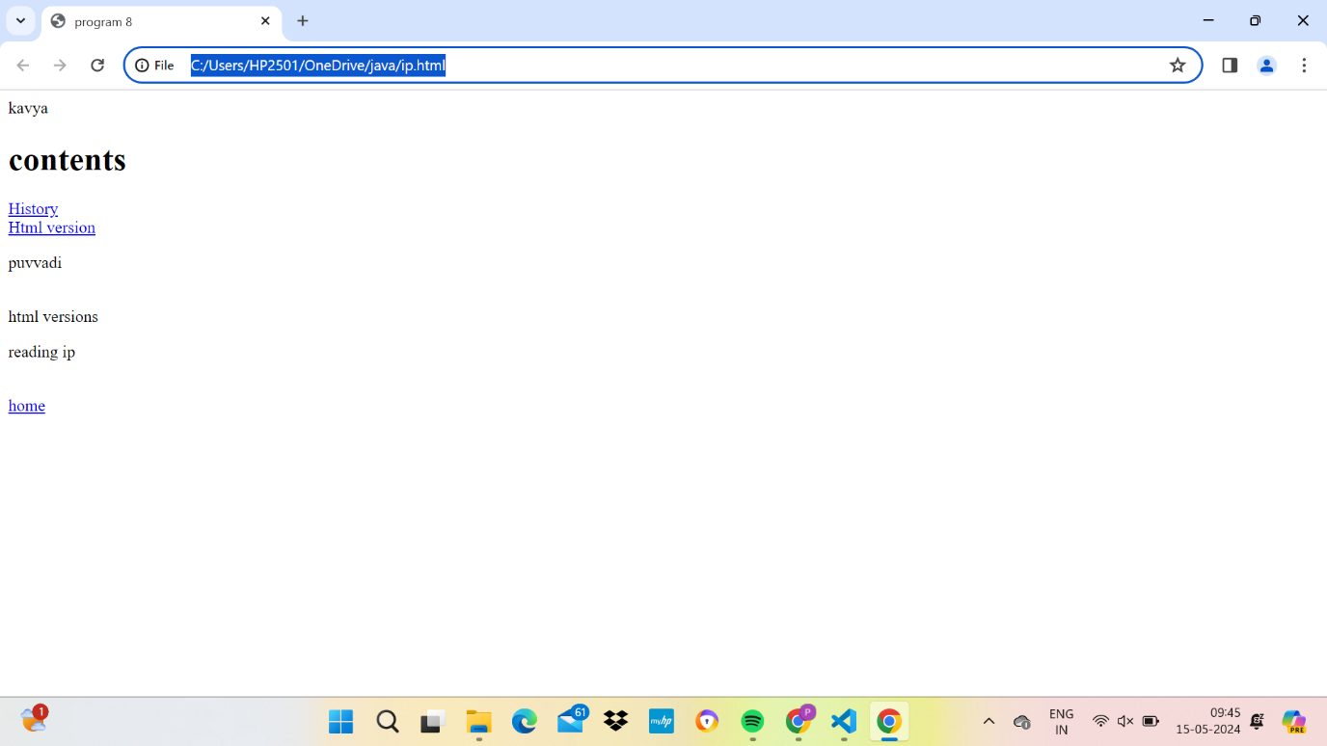

Program 9

<html>

<head>

<title>program 09</title>

</head>

<body bgcolor="pink">

<font color="red"><marquee direction="left">

Welcome to AITS TIRUPATI</marquee></font>

</body>

</html>

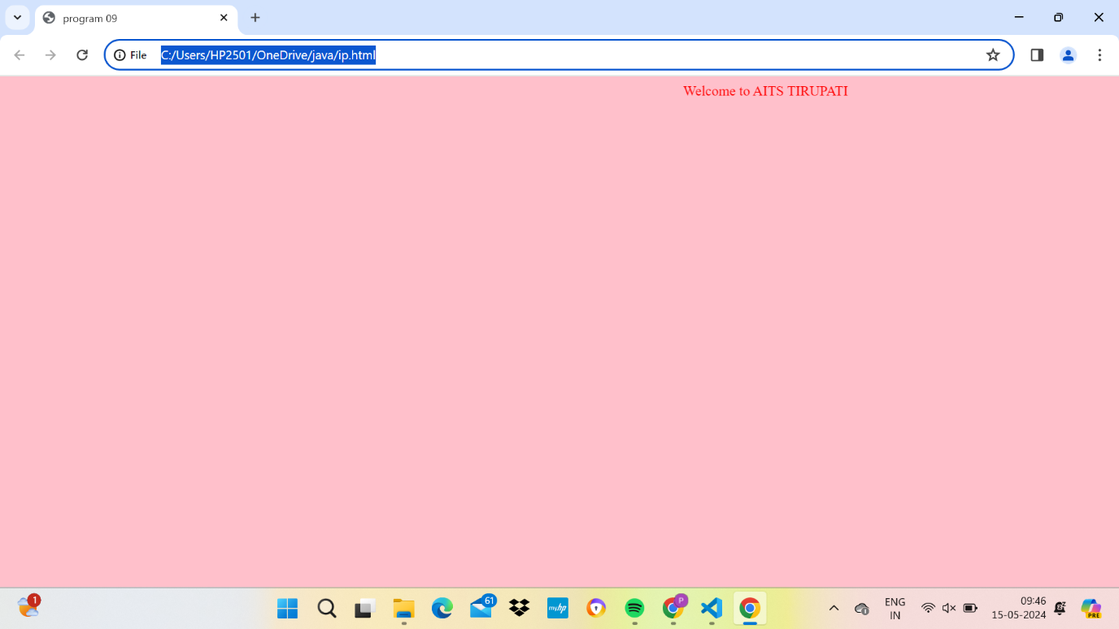

Program 10

<html>

<head>

<title>program 09</title>

</head>

<body>

<ol>

<li>English </li>

<li>Maths-2</li>

<li>Digital Electronics & computer

fundamentals</li> <li>Basic Web design lab</li>

<li>multimedia lab</li>

<li>digital electronics</li>

</ol>

</body>

</html>

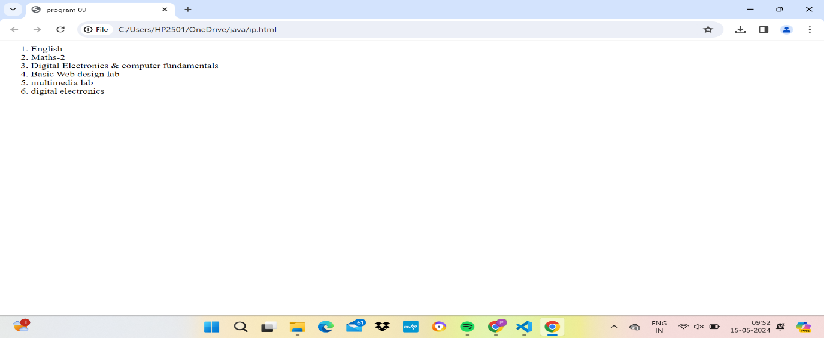

Program 11

<html>

<head>

<title>program 11</title>

</head>

<body>

<ul>

<li> Computer science and Engg </li>

<li> Electronics and communication </li>

<li> Civil Engg </li>

<li> Mechanical Engg</li>

</ul>

</body>

</html>

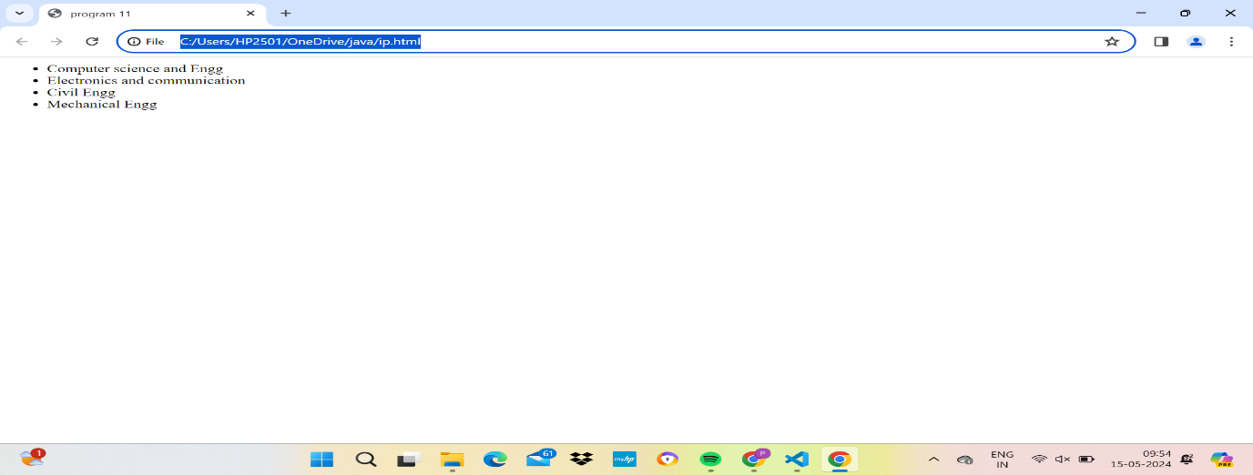

Program 12

<html>

<head><title>program 12</title>

</head>

<body>

<ol type=1>

<li>chapter 1</li>

<ol type=1>

<li>section one</li>

<li>section two</li>

</ol type=1>

<li>chapter 2</li>

<ol type=1>

<li>section one</li>

<li>section two</li>

</ol>

</ol>

</body>

</html>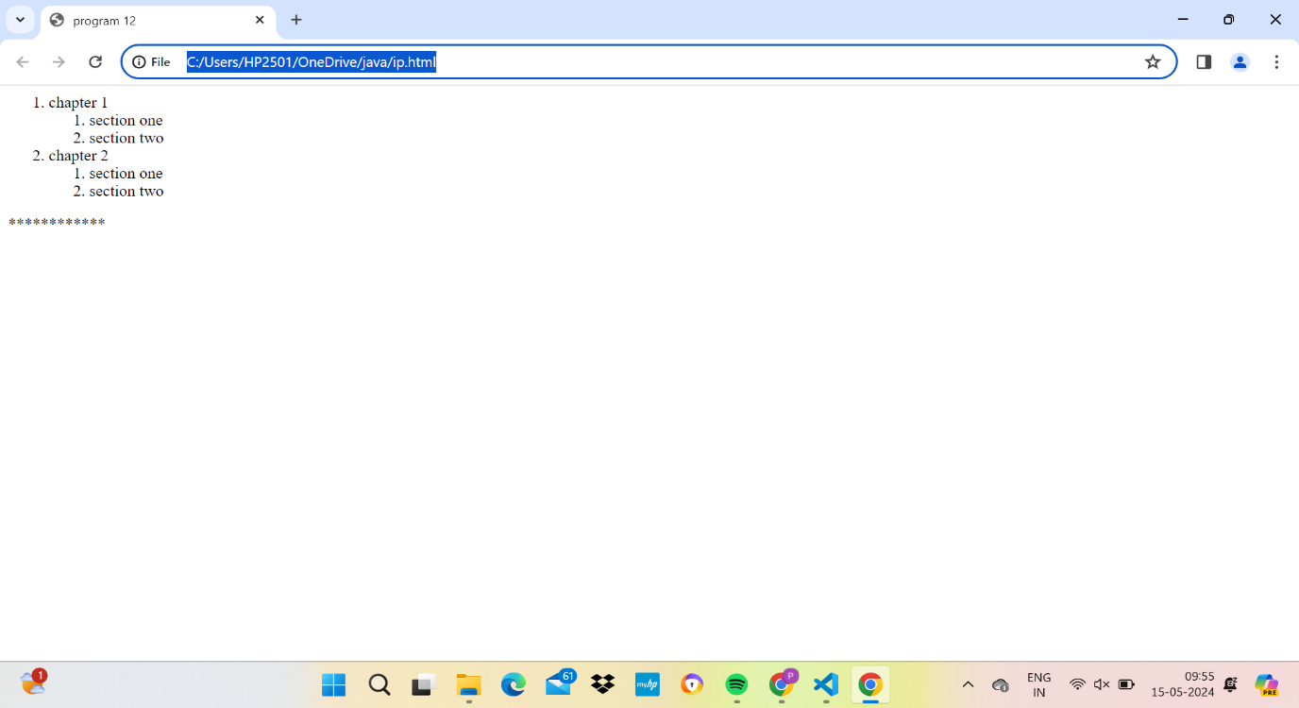

Program 13<html>

<head>

<title>program 13</title>

</head>

<body>

<table border= "1">

<tr>

<th> reg.number</th>

<th> student name</th>

<th> year/semester </th>

<th>date of admission</th>

</tr>

<tr>

<td> 20AK1A0501</td>

<td> suma</td>

<td> 2nd</td>

<td> 06/06/2012 </td>

</tr>

<tr>

<td> 20AK1A0502 </td>

<td> xyz</td>

<td>2nd</td>

<td> 07/07/2012 </td>

</tr>

</table>

</body>

</html>

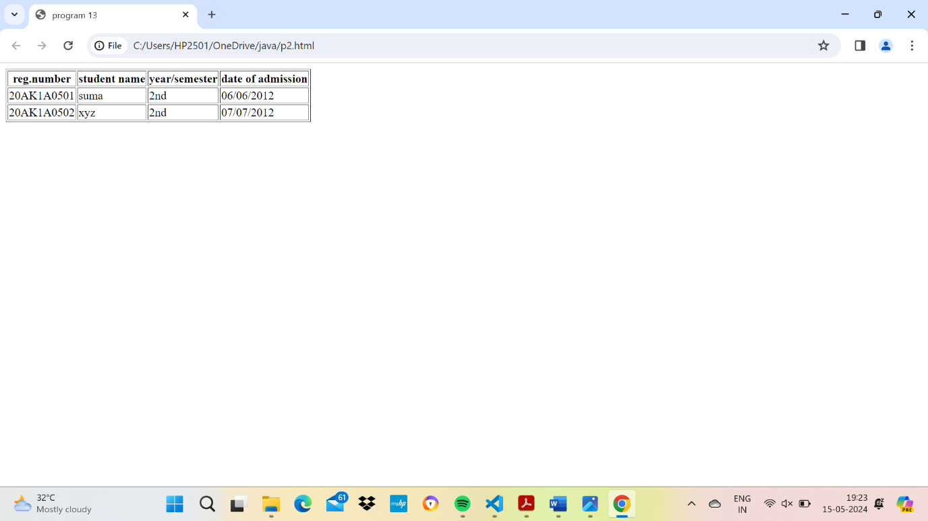

Program 14

<html>

<frameset cols="*,*">

<frame src="Horse-neighing.mp3">

<frame src="ARRRRR Horse.mp4-2.mp4">

</frameset>

</html>

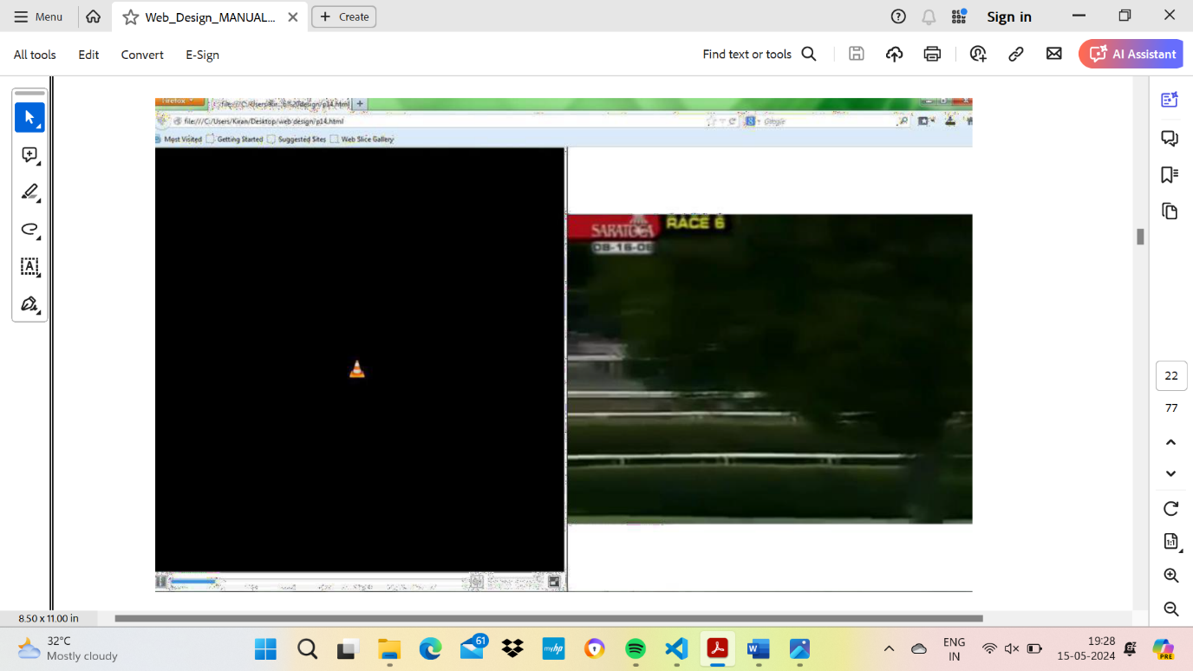

Program 15

<html>

<frameset cols="*,*">

<frame src="ARRRRR Horse.mp4-2.mp4" name="left">

<frameset rows="50%,50%">

<frame src="Horse-neighing.mp3" name="topright">

<frame src="ARRRRR Horse.mp4-2.mp4" name="topbuttom">

</frameset>

</frameset>

</html>

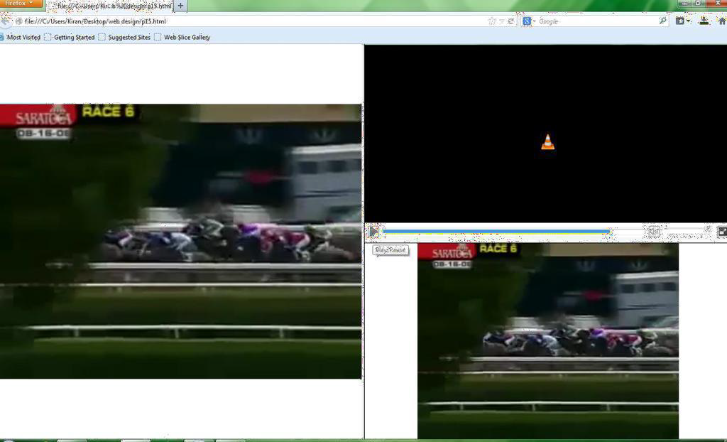

Program 16

<html>

<body>

<style>

body {

background-color:blue;

}

h1 {

color:orange;

text-align:center;

}

p {

font-family: "Times New Roman";

font-size: 20px;

}

</style>

<h1>My First CSS Example</h1>

<p>This is a audio.</p>

<audio controls>

<source src="Horse-neighing.mp3">

</audio>

</body>

</html>

Dept.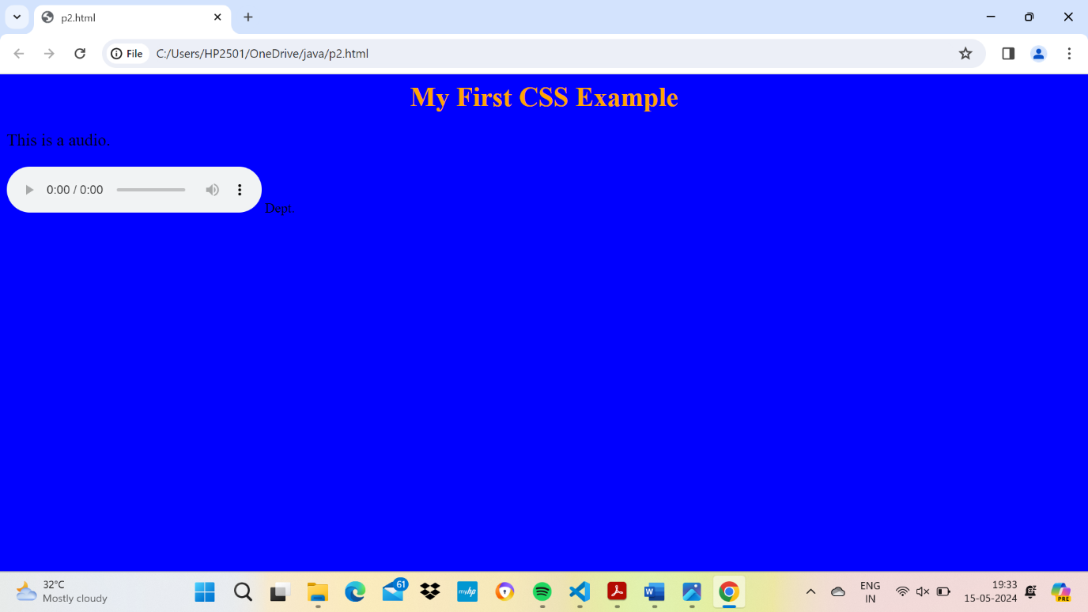

Program 17

<html>

<head>

<title>AITS COLLEGE INFASTRUCTURE</title>

</head>

<body>

<table width = "100%" border = "0">

<tr>

<td colspan = "2" bgcolor = "pink">

<center><h1>AITS COLLEGE INFASTRUCTURE</center></h1>

</td>

</tr>

<tr valign = "top">

<td bgcolor = "linen" width = "50">

<b>DEPARTMENTS</b><br><br>

1.COMPUTER SCIENCE AND ENGINEERING<br>

2.ELECTRONICS COMMUNICATION AND ENGINEERING<br>

3.CIVIL ENGINEERING<br>

4.MECHANICAL ENGINEERING <br>

5.ELECRICAL ELECTRONICS AND ENGINEERING <br>

</td>

<td bgcolor = "lightblue" width = "100" height = "200">

LABS AND CLASSROOMS

</td>

</tr>

<tr>

<td colspan = "2" bgcolor = "#b5dcb3">

<center>

Department of CSE

</center>

</td>

</tr>

</table>

</body>

</html>

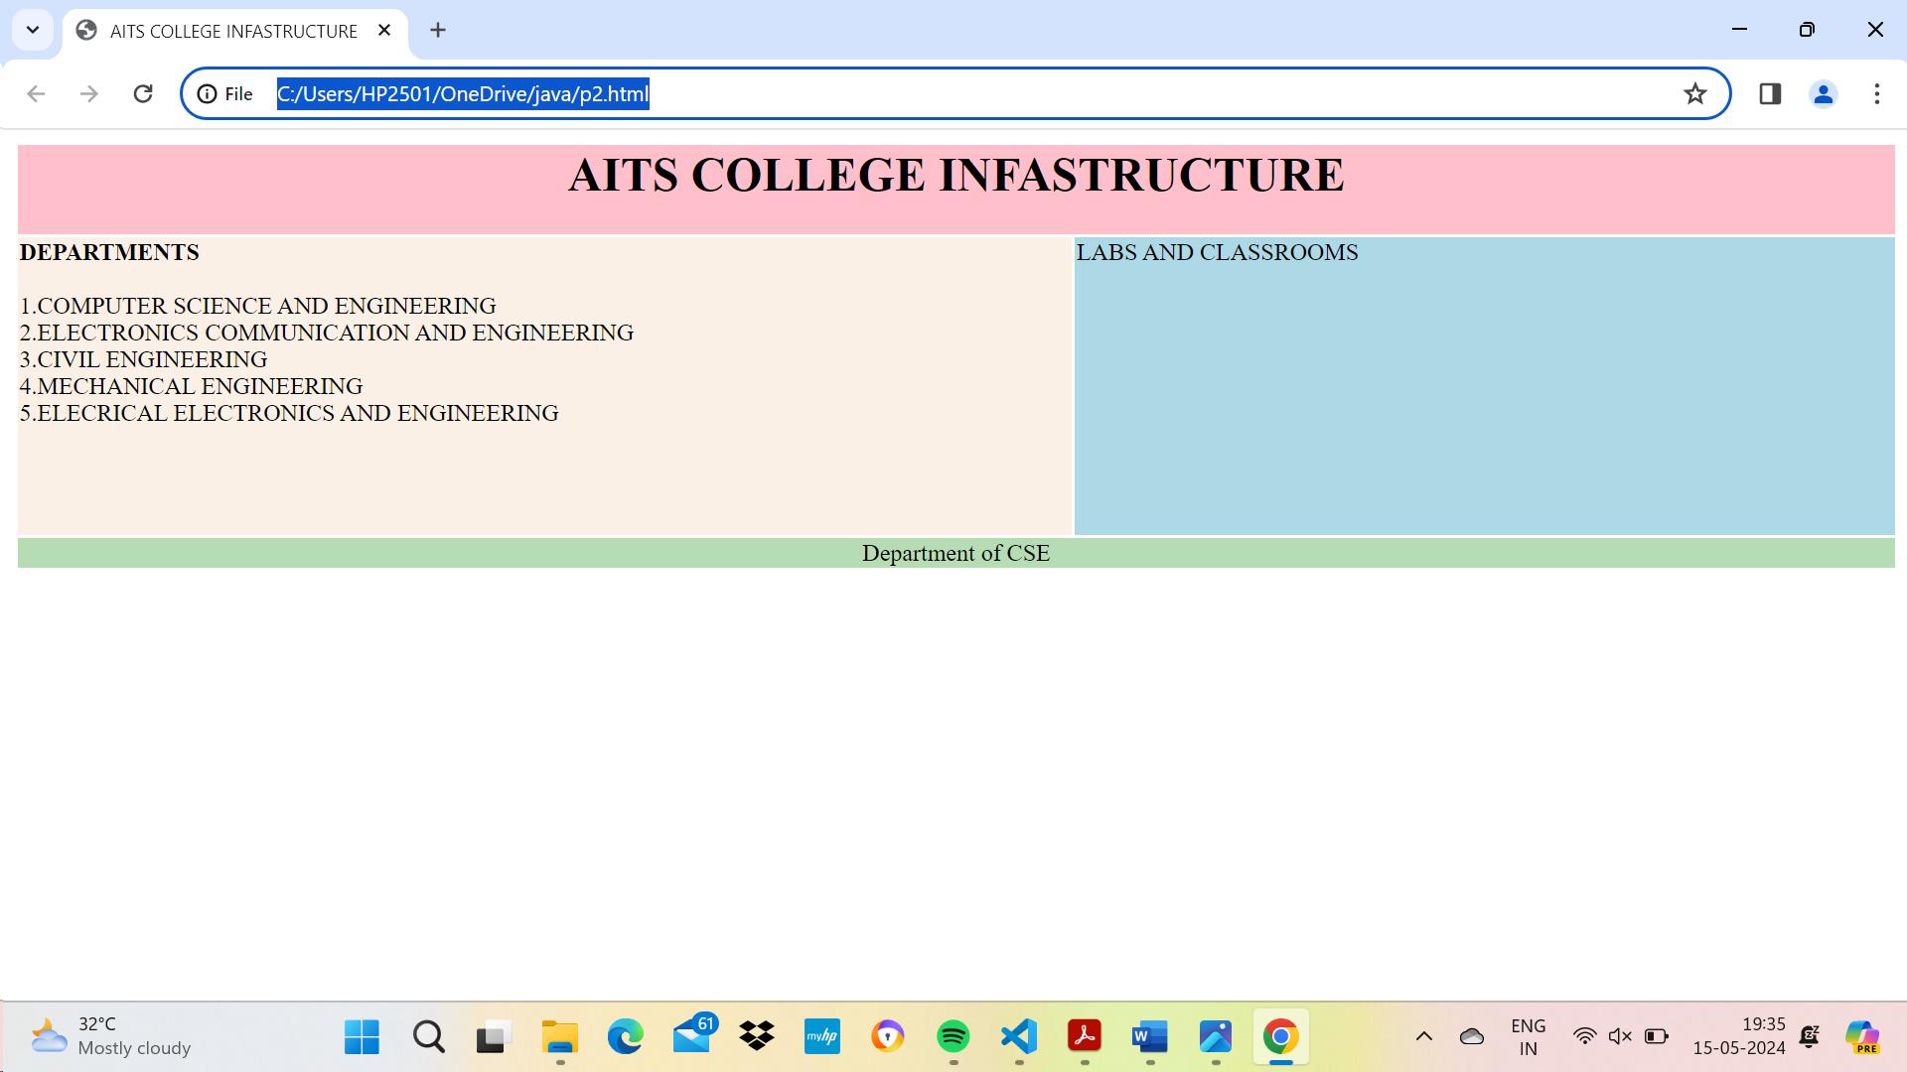

Program 18

<!DOCTYPE html>

<html>

<head>

<style>

.myDiv {

border: 5px outset red;

background-color: lightblue;

text-align: center;

}

</style>

</head>

<body>

<h1>The div element</h1>

<div class="myDiv">

<h2>This is a heading in a div element</h2>

<p>This is some text in a div element.</p>

</div>

<p>My mother has <span style="color:blue;font-weight:bold">blue</span> eyes and my father has <span

style="color:darkolivegreen;font-weight:bold">dark green</span> eyes.</p>

<p>This is some text outside the div element.</p>

</body>

</html>

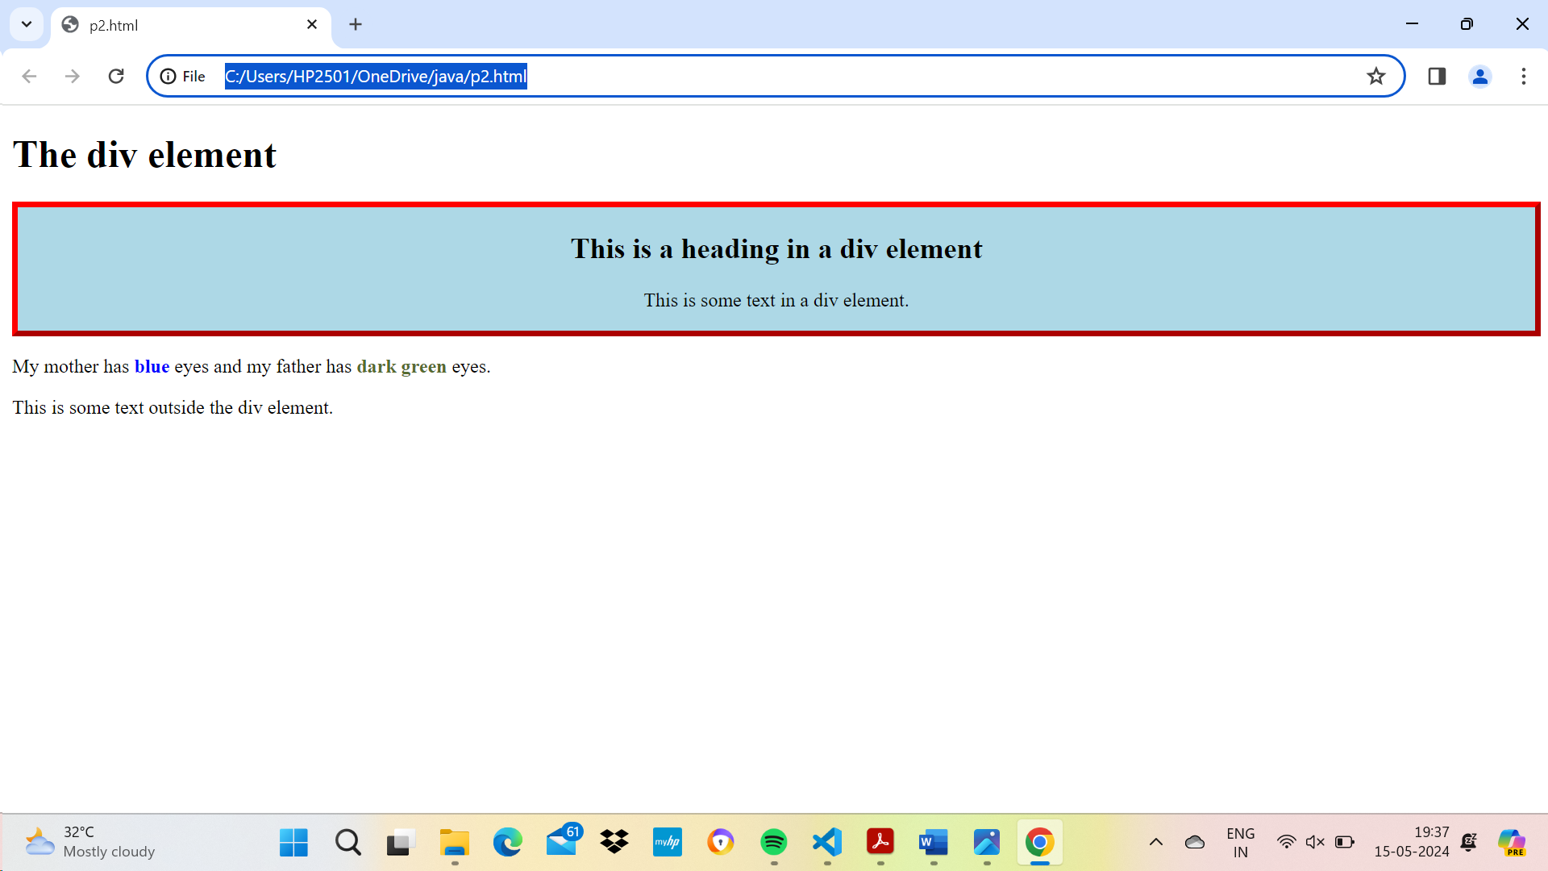

Program 19

<!DOCTYPE html>

<html>

<head>

<title>HTML Frames</title>

</head>

<frameset cols="20%,*">

<frame src="left-frame.html">

<frameset rows="60%,*">

<frame src="right-top-frame.html">

<frame src="right-bottom-frame.html">

</frameset>

</frameset>

</html>

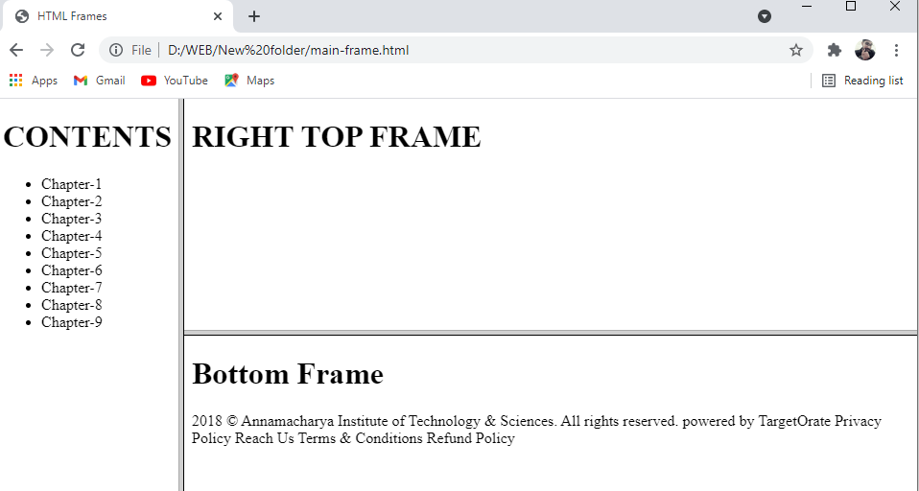

<!DOCTYPE html>

<html>

<head>

<title>HTML Frames</title>

</head>

<body>

<h1>CONTENTS</h1>

<ul>

<li>Chapter-1</li>

<li>Chapter-2</li>

<li>Chapter-3</li>

<li>Chapter-4</li>

<li>Chapter-5</li>

<li>Chapter-6</li>

<li>Chapter-7</li>

<li>Chapter-8</li>

<li>Chapter-9</li>

</ul>

</body>

</html>

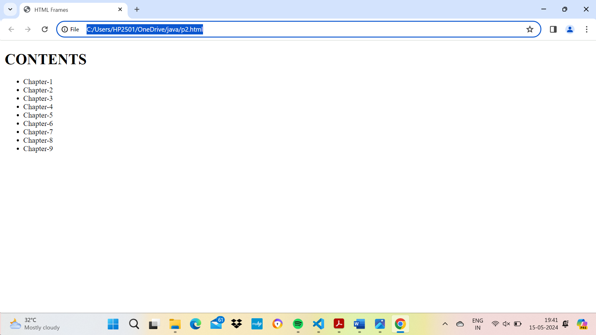

<!DOCTYPE html>

<html>

<head>

<title>HTML Frames</title>

</head>

<h1>RIGHT TOP FRAME</h1>

</html>

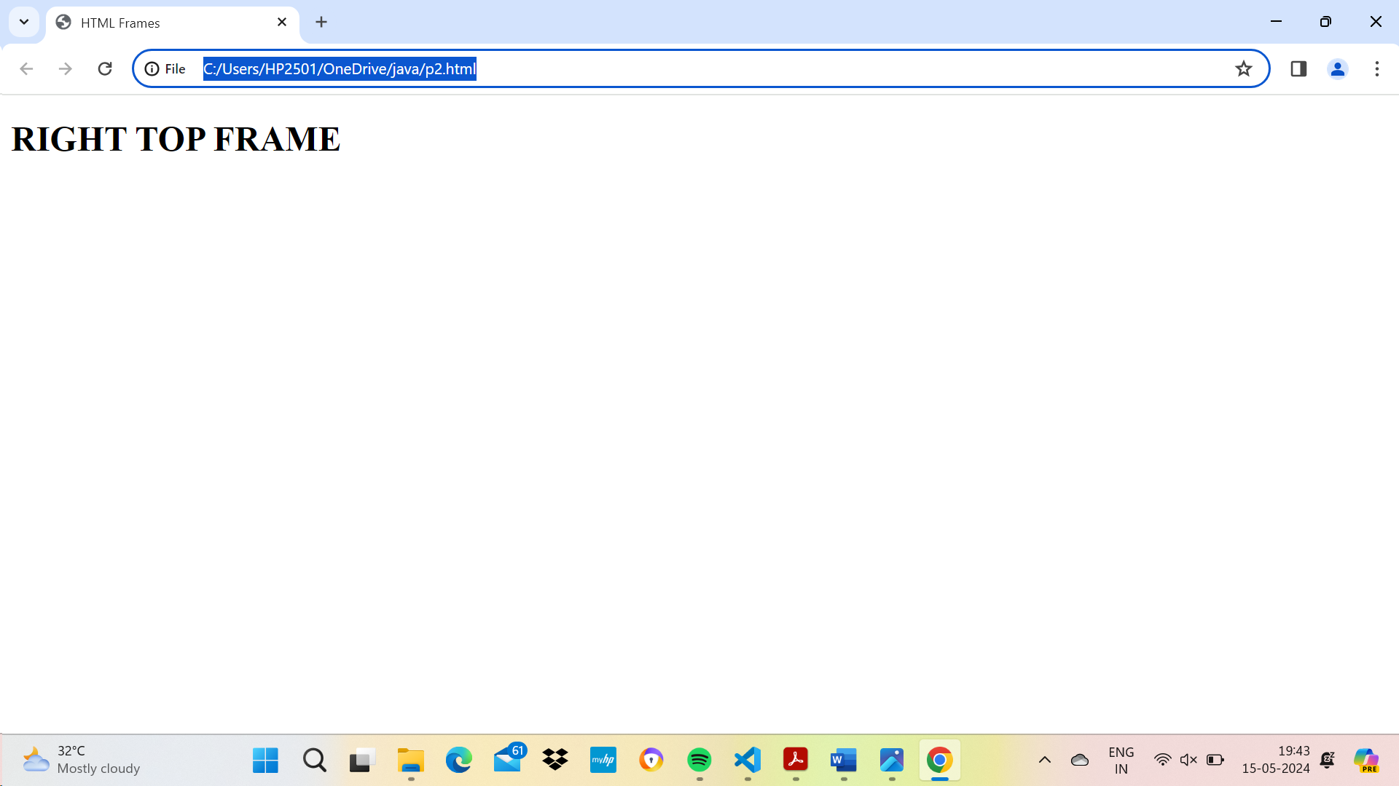

**Save file as right-bottom-frame.html**

<!DOCTYPE html>

<html>

<head>

<title>HTML Frames</title>

</head>

<body>

<h1>Bottom Frame</h1>

2018 © Annamacharya Institute of Technology & Sciences. All rights reserved.

powered by TargetOrate

Privacy Policy Reach Us Terms & Conditions Refund Policy

</body>

</html>

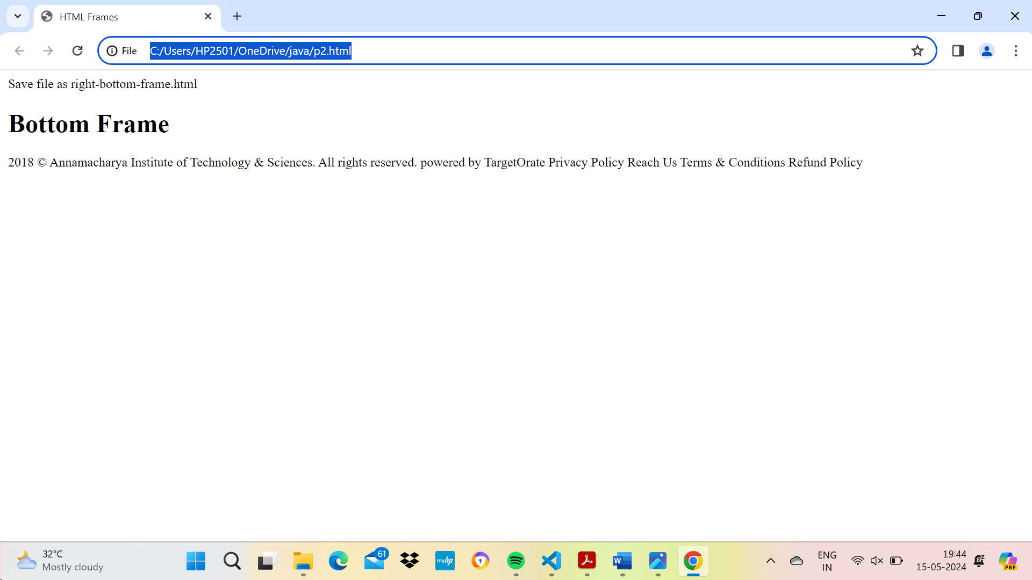

Program 20

<html>

<head><title>AUDIO/VIDEO</title>

<style>

body{

background-image:url('huts.jpg');

background-size:100% 100%;

}

.video{

color:white;

text-align:center;

}

.audio{

color:white;

text-align:left;

}

</style>

</head>

<body>

<div class="video">

<h2><i> <u>Video's</u></i> </h2>

<!--Video Muted -->

<video controls muted>

<source src="D:\video\inspire.mp4" type="video/mp4">

</video>

<!--Video Autoplay-->

<video width="320" height="240" autoplay>

<source src="D:\video\inspire.mp4" type="video/mp4">

</video>

<video controls>

<source src="D:\video\inspire.mp4" type="video/mp4"

type="video/mp4">

</video>

</div>

<br>

<div class="audio">

<h2><i> <u>Audio</u></i> </h2>

<!--AUDIO Autoplay-->

<audio controls>

<source src="D:\my music\final.mp3"

type="audio/mp3">

</audio>

</div>

</body>

</html>

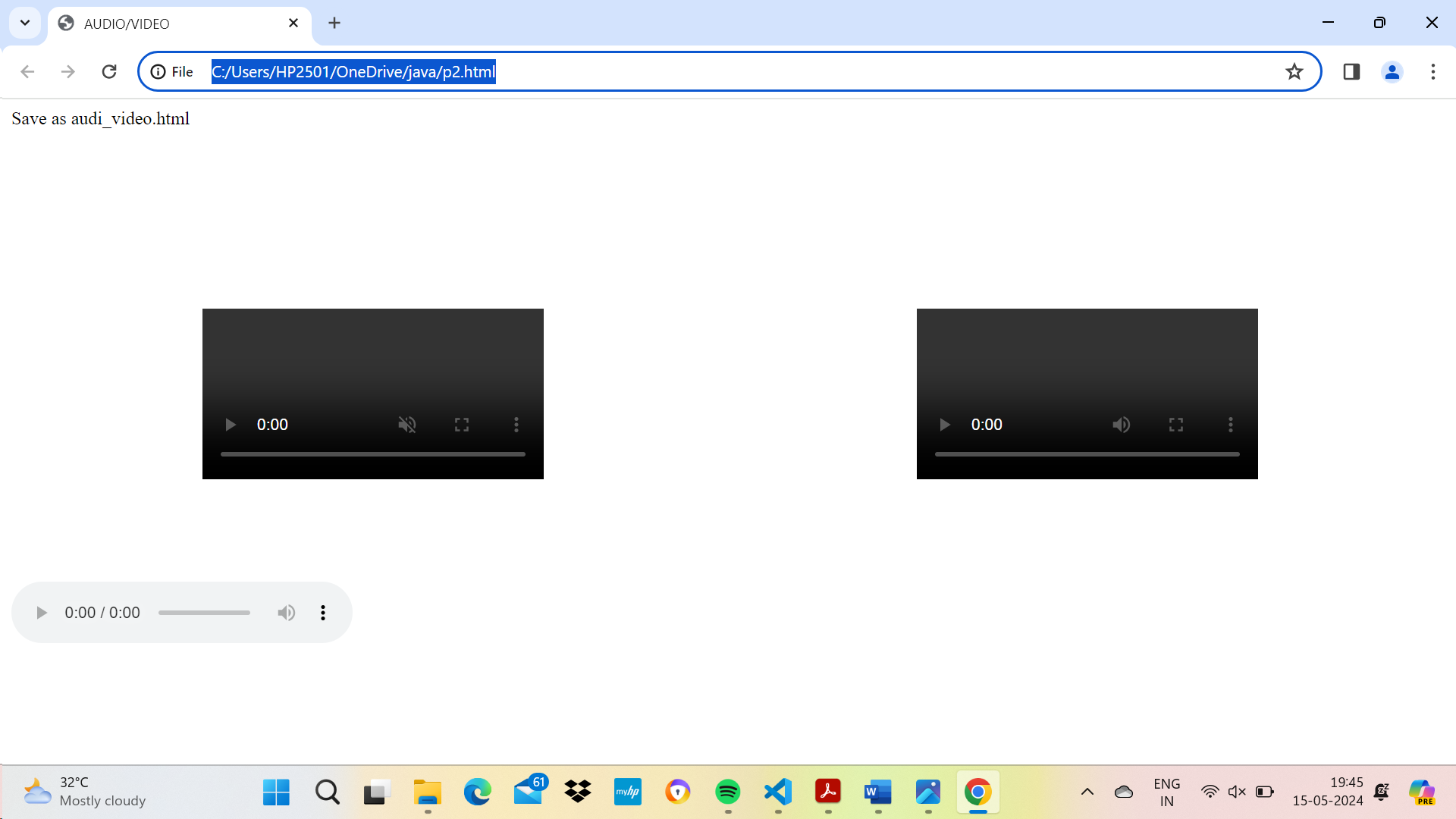

Program 21



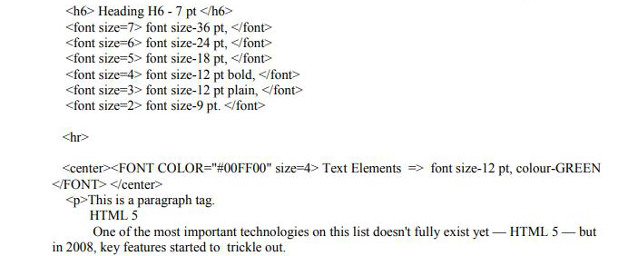







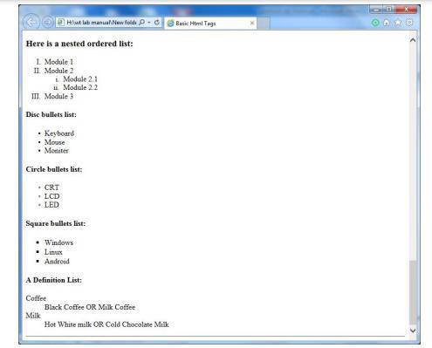

Program 22

<html >

<head>

<title>Font Elements</title>

<style>

body { font-family: Verdana, sans-serif; background-color:yellow;}

h1 { font-size: 450%; }

p{ font-style : italic;}

.underline{text-decoration: underline}

.overline{text-decoration: overline}

.linethrougn{text-decoration:line-through}

.bold{font-weight:900}

</style>

</head>

<body bgcolor="green">

<font color="white">Welcome to WEB-PAGE</font>

<h1>Heading in verdana family and with font size 450</h1>

<p>Paragraph in Italic style</p>

<div class="bold">

<div class="underline">

<p>Underline Text</p>

</div>

<div class="overline">

<p>Overline Text</p>

</div>

<div class="linethrougn">

<p>Overline Text</p>

</div>

</div>

</body>

</html>

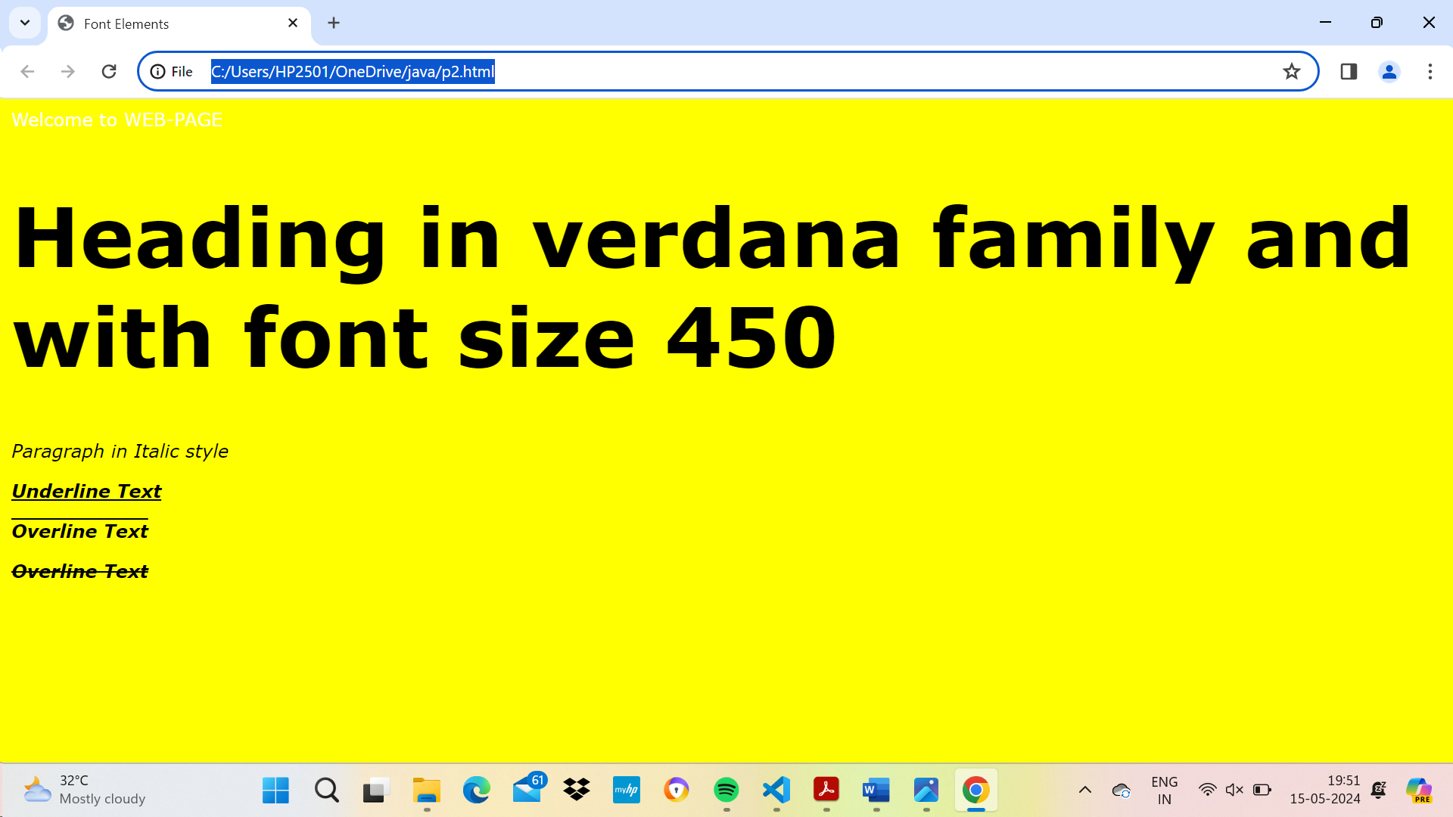

Program 23

<html >

<head>

<title>Font Elements</title>

</head>

<body>

<h1 style="background-color:blue;color:yellow">Link to Wikipedia</h1>

<hr>

<a href="https://en.wikipedia.org/wiki/Wi-Fi">-Wi-Fi</a>

<hr>

<a href="https://en.wikipedia.org/wiki/Local_area_network">-LAN</a>

<hr>

</body>

</html>

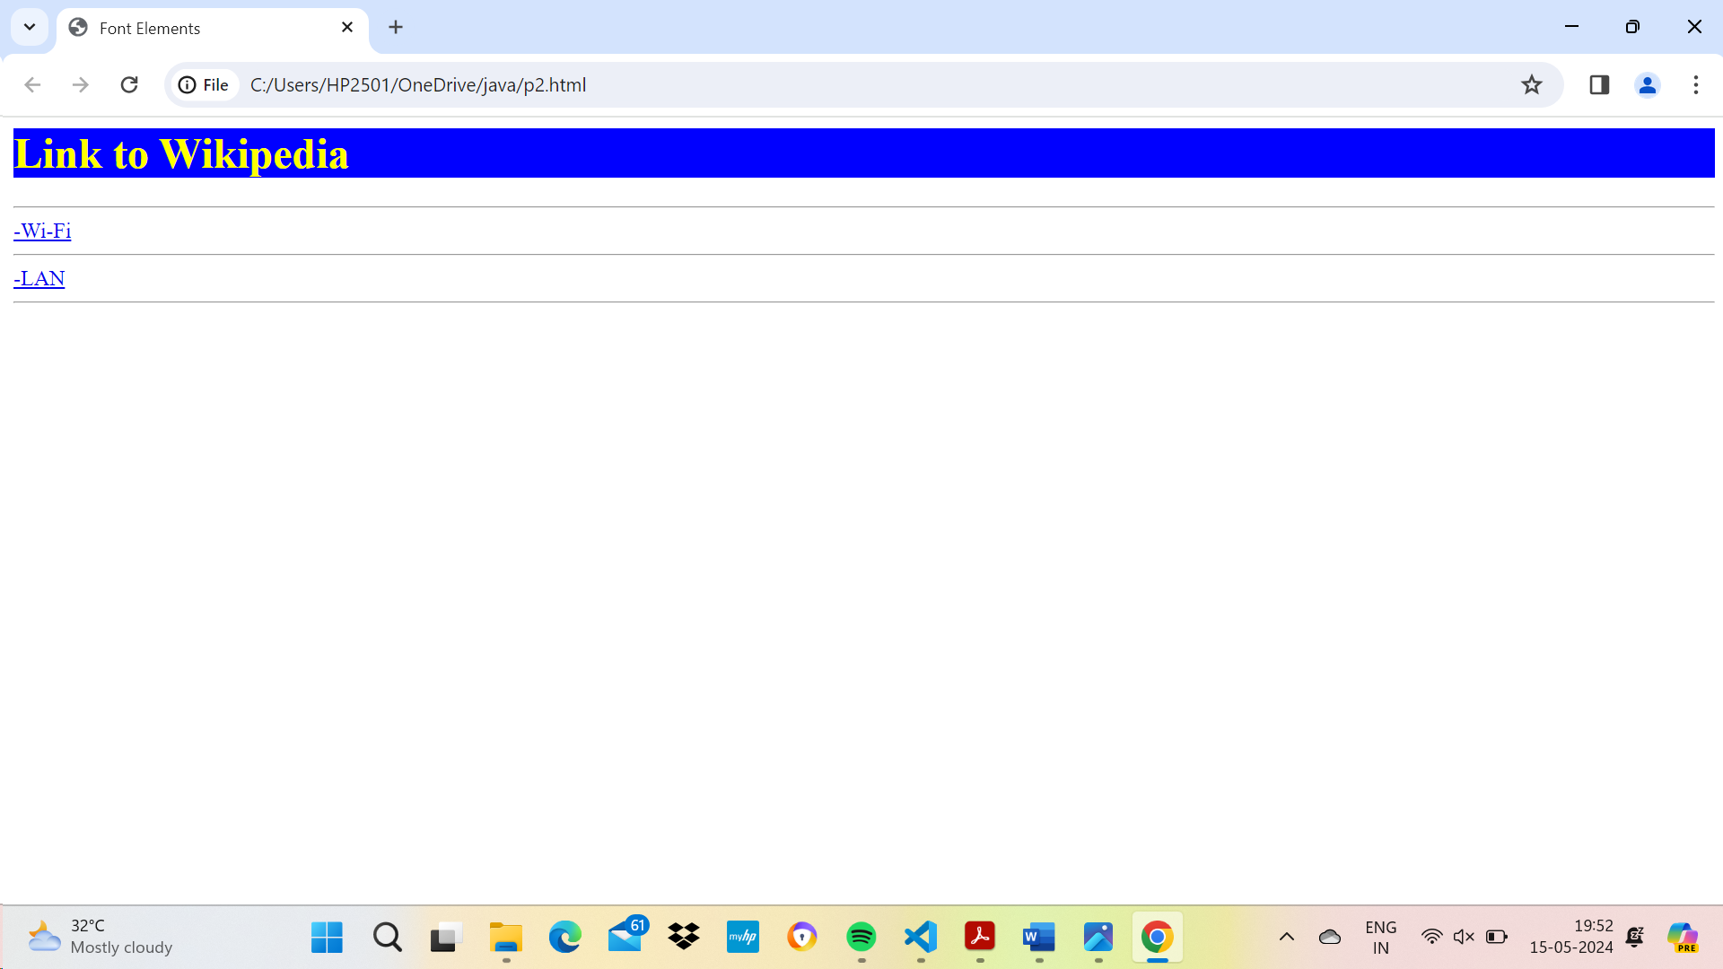

Program 24

<html>

<head>

<title>program 24</title>

</head>

<body style="background-color:black;">

<center>

<a href="program2.html">

<img src=" thumb-1920-345366.jpg" width="700" height="300"/>

</a>

<font size=6px>

<p style="color:white";>Click Image</p>

</font>

</center>

</body>

</html>

**program2.html**

<html>

<head>

<title>Another HTML Page</title>

</head>

<body>welcome to HTML page</body>

</html>

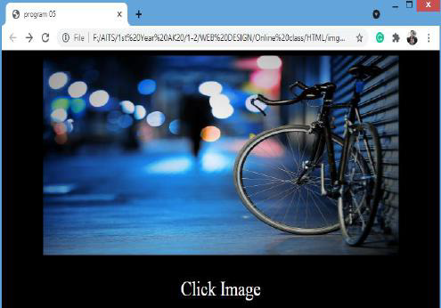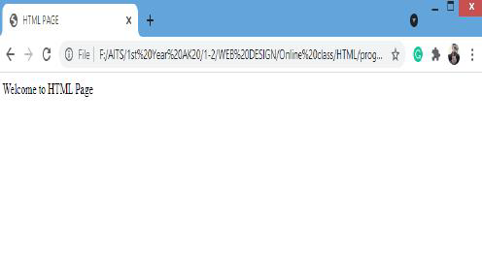

Program 25

<html>

<head>

<title>program 05</title>

</head>

<body style="background-color:yellow;">

<center>

<h1 style="color:blue;"> Annamacharya Institute of Technology & Sciences, Tirupati <br>

(Autonomous) </h1>

<p style="color:blue;">Approved by AICTE, New Delhi & Permanent Affiliation to JNTUA,

Anantapuramu.<br>

Two B.Tech Programmes (CSE & ECE) are accredited by NBA, New Delhi.

<br>

Accredited by NAAC with 'A' Grade, Bangalore. Accredited by Institution of Engineers (India),

KOLKATA.<br>

A-grade awarded by AP Knowledge Mission. Recognized under sections 2(f) & 12(B) of UGC Act

1956.</p>

</center>

<h1 style="background-color:red"><marquee>Welcome to AITS WEB PAGE</marquee></h1>

<font size=5px>

<p style="color:blue;text-align:left"><strong style="color:red">Artificial Intelligence and Data

Science</strong>

<hr>

<br>In recent years, Artificial Intelligence and Data Science has gained presence in all areas of

life. <br>Data science is an inter-disciplinary field that uses scientific methods, processes,

algorithms and systems to extract knowledge, insights from heterogeneous data using artificial

intelligence. This programme seeks to determine the importance of Artificial Intelligence and

Data Science and its real-time applications in all aspects of life.

<br><br>

The <b>B.Tech</b> program in <b>Artificial Intelligence and Data Science</b> is started in the

academic year 2020 – 21 with an intake of 60 and has increased the intake to 120 from the

academic year 2021 – 22.

</p>

<p><strong style="color:red">Computer Science and Engineering (CSE)</strong><hr>

<b>M.Tech (Computer Science and Engineering)</b> is a two year full time post-graduate

programme approved by the All India Council of Technical Education (AICTE) for the students

who have a B.E / B. Tech in any branch of engineering, M.Sc and M.C.A. The course is offered by

the Department of Computer Science & Engineering by highly qualified and experienced teaching

faculty. Intake to this course is 18 admitted through J N T University’s.

<br><br>

The <b>B.Tech CSE </b>Programme was accredited by NBA first time under tier – II in 2016

and further extension of accreditation in granted up to June 2023.</p>

</font>

<h3><a href="#up">Click here to go UP</a></h3>

</body>

</html>

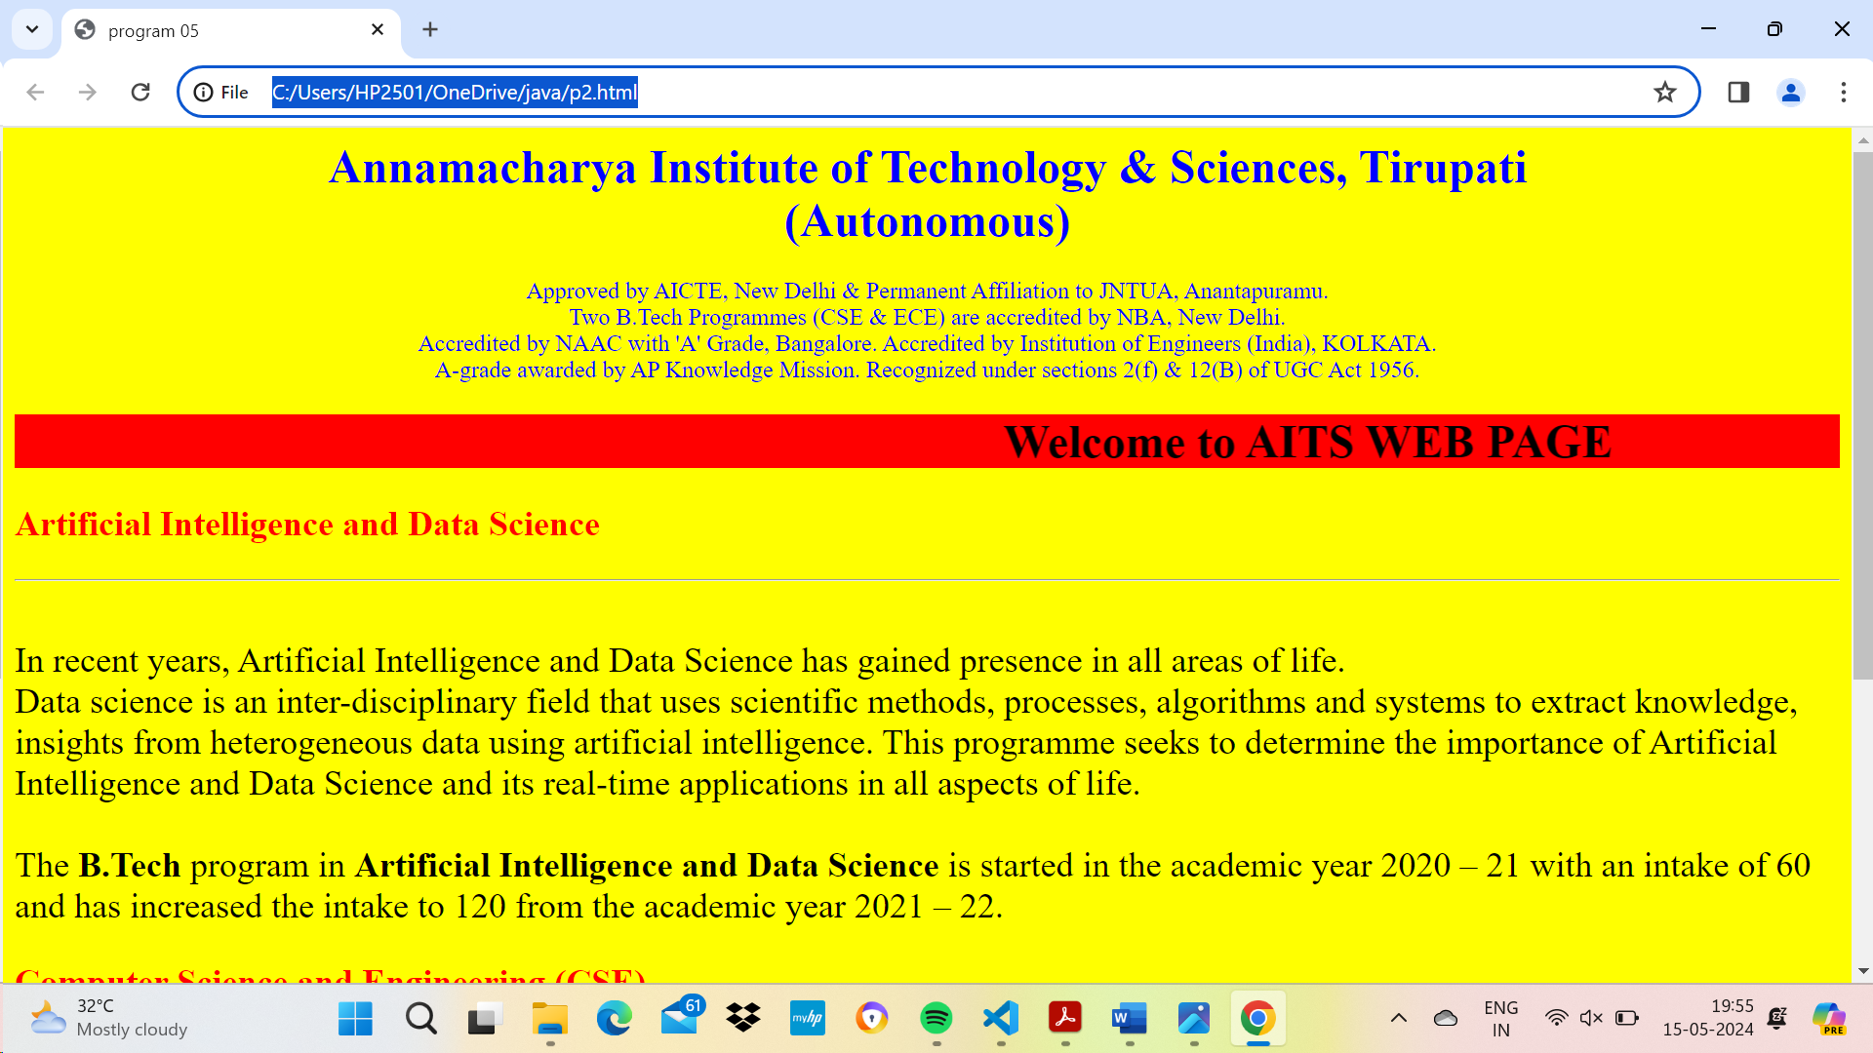

Program 26

<html>

<body bgcolor=”pink”>

<br><br>

<marquee><h1 align=”center”><b><u>ONLINE BOOK

STORAGE</u></b></h1></marquee>

</body>

</html>

**Right.html:**

<html>

<body bgcolor="gray">

<br><br><br><br><br>

<h2 align="center">

<b><p> welcome to online book storage. Press login if you are

having id otherwise press registration.

</p></b></h2>

</body>

</html>

**Left.html:**

<html>

<body bgcolor="gray">

<h3>

<ul>

<li><a href="login.html" target="right"><font color="black">

LOGIN</font></a></li><br><br>

<li><a href="reg.html" target="right"><font color="black">

REGISTRATION</font></a></li><br><br>

<li><a href="profile.html" target="right"><font color="black">

USER PROFILE</font></a></li><br><br>

<li><a href="catalog.html" target="right"><font color="black">

BOOKS CATALOG</font></a></li><br><br>

<li><a href="scart.html" target="right"><font color="black">

SHOPPINGCART</font></a></li><br><br>

<li><a href="payment.html" target="right"><font color="black">

PAYMENT</font></a></li><br><br>

<li><a href="order.html" target="right"><font color="black">

ORDER CONFIRMATION</font></a></li><br><br>

</ul>

</body>

</html>

**Main.html:**

<frameset rows=”25%, 75 %”>

<frame src=”top.html” name=”top”>

<frameset cols=”25%,75%”>

<frame src=”left.html” name=”left”>

<frame src=”right.html” name=”right”>

</frameset>

</frameset>



**Login.html:**

<html>

<head>

<title>Form Tags</title>

</head>

<body bgcolor="gray">

<center>

<h1 style="color:white">LOGIN FORM</h1>

<!--input-->

<img src="user.png" height="15px" width="20px"><input type="text" placeholder="USER

NAME"><br><br>

<!--password-->

<img src="lock.png"height="15px" width="20px"><input type="password"

placeholder="PASSWORD"><br><br>

<!--button-->

<input type="submit" value="Submit">

<input type="reset" value="clear">

</center>

</body>

</html>

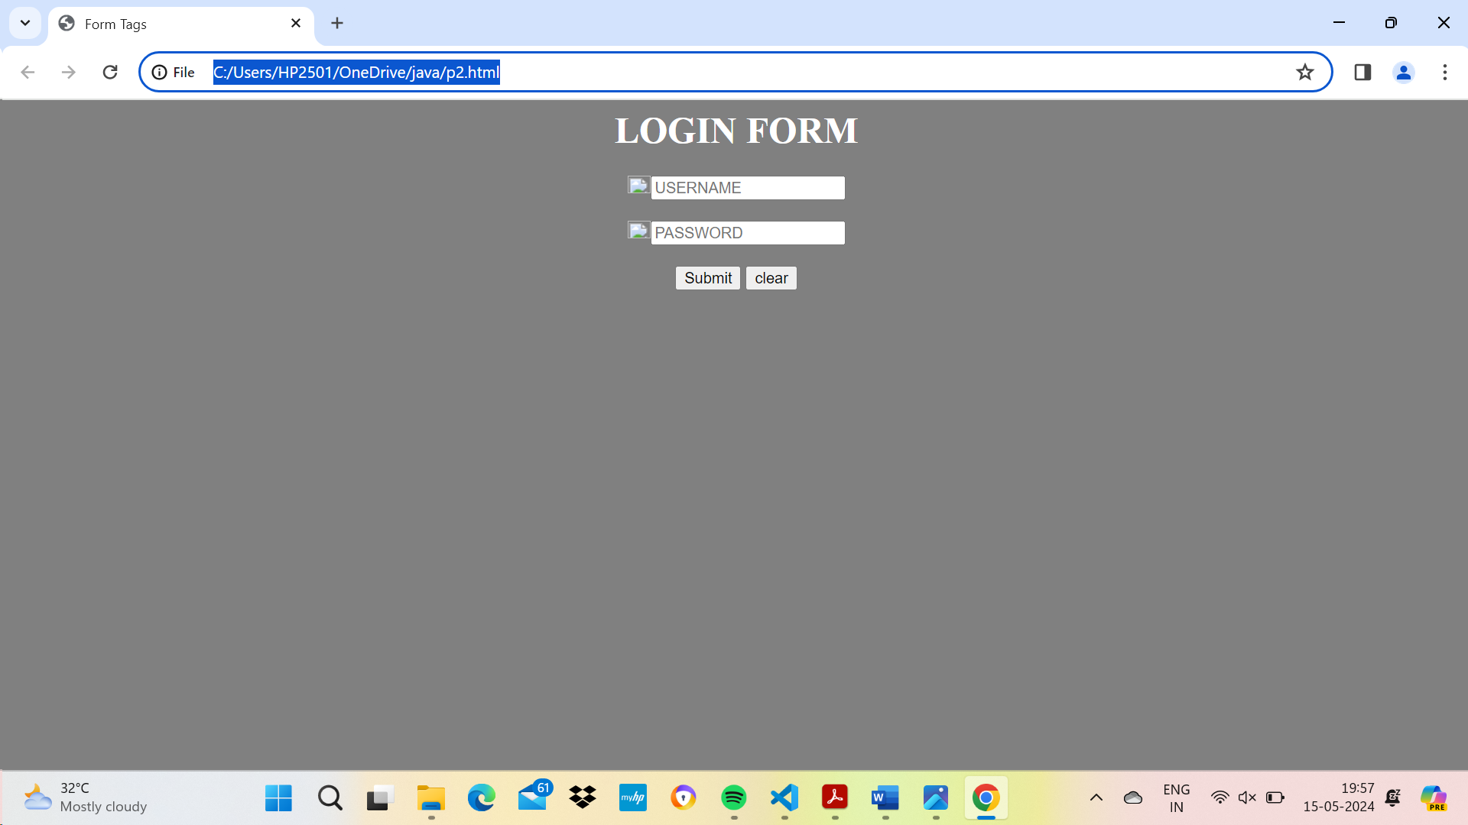

**Book Catalog.html:**

<html>

<body bgcolor="gray"><br><br><br>

<div align="center"><pre>

BOOK TITLE :<input type="text" name="title"><br>

</pre><br><br>

</div>

<br><br>

<div align="center">

<input type="submit" value="ok" name="button1">&nbsp;&nbsp;&nbsp;&nbsp;

<input type="reset" value="clear" name="button2">

</body>

</html>

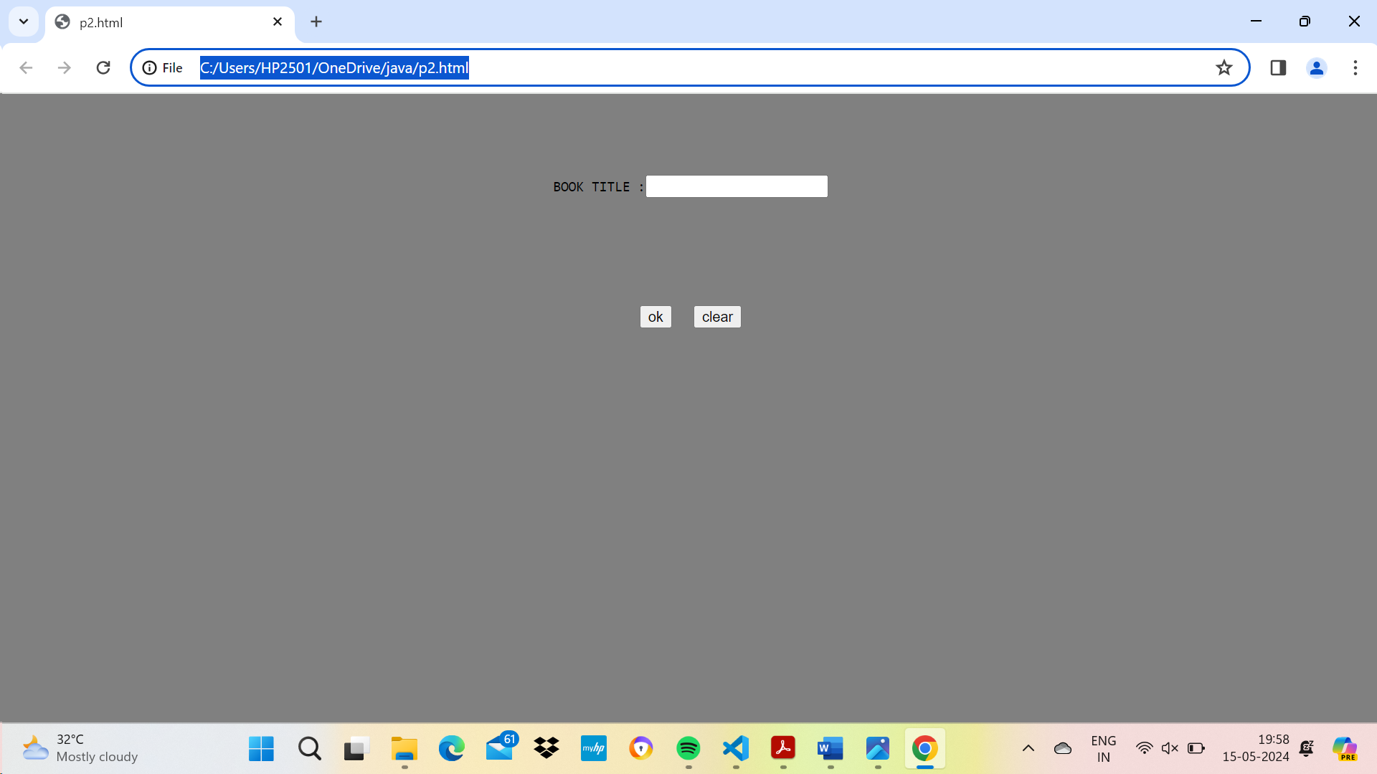

**Order.html**:

<html>

<body bgcolor="gray"><br><br><br>

<h1 align="center">ORDER CONFIRMATION</h1>

<div align="center"><table>

<tr><td>LOGIN ID:</td><td><input type="text" name="id"></td></tr>

<tr><td>TITLE:</td><td><input type="text" name="title"></td></tr>

<tr><td>NO.OF BOOKS:</td><td><input type="text" name="no"></td></tr>

<tr><td>COST OF BOOK:</td><td><input type="text" name="cost"></td></tr>

<tr><td>DATE:</td><td><input type="text" name="date"></td></tr>

</div>

<br><br>

<tr align="center"><td><input type="submit" value="ok" name="button1"></td>

<td><input type="reset" value="clear" name="button2"></td></tr>

</table>

</body>

</html>

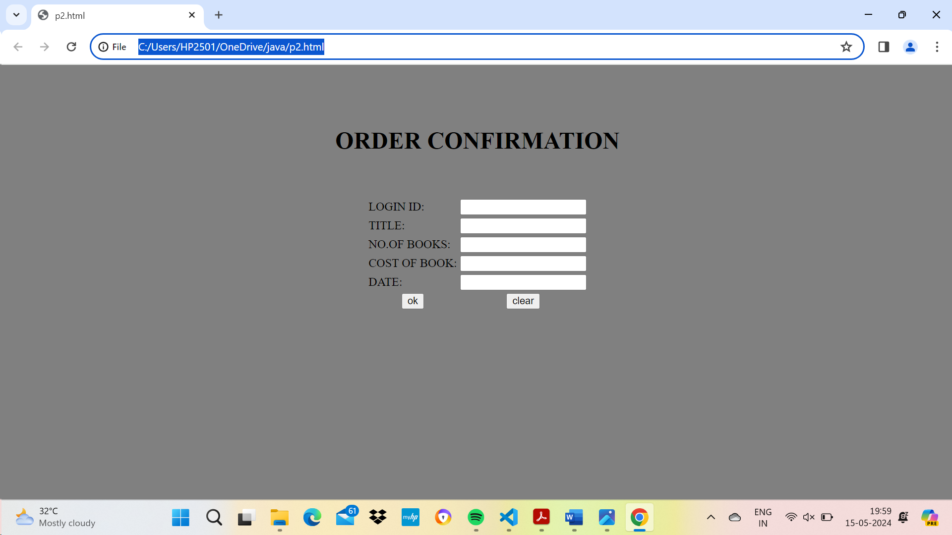

**Payment.html:**

<html>

<body bgcolor="gray"><br><br><br>

<form>

<div align="center">

<table>

<tr><td>LOGIN ID:</td><td><input type="text" name="id"></td></tr>

<tr><td>PASSWORD:</td><td><input type="password" name="pwd"></td></tr>

<tr><td>AMOUNT:</td><td><input type="text" name="amount"></td></tr>

<tr><td>CREDITCARDNUMBER:</td><td><input type="PASSWORD"

name="num+"></td><br><br><br>

</div>

<tr><td><input type="submit" value="ok"></td>

<td><input type="reset" value="clear"></td></tr>

</table>

</form>

</body>

</html>

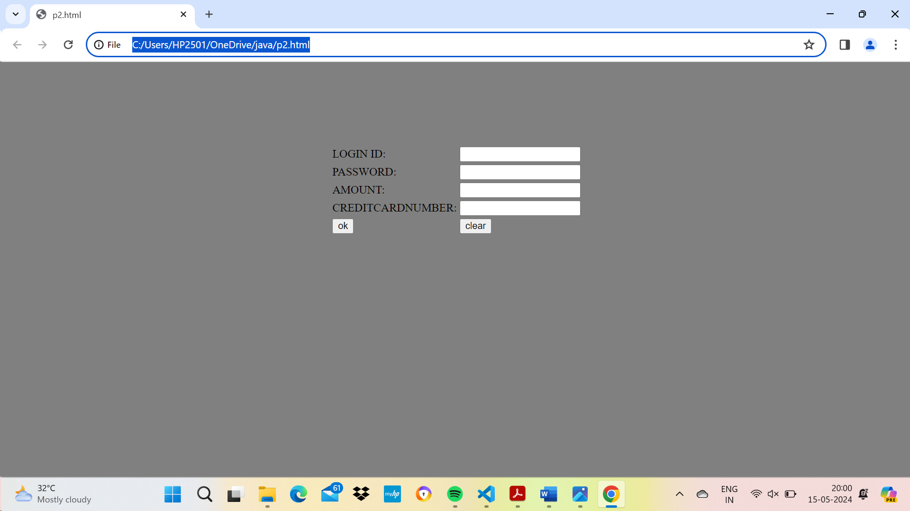

**Profile.html:**

<html>

<body bgcolor="gray"><br><br><br>

<form name="myform">

<div align="center"><pre>

LOGIN ID:<input type="text" name="id"><br>

PASSWORD:<input type="password" name="pwd"></pre>

</div>

<div align="center">

<input type="submit" value="ok">&nbsp;&nbsp;&nbsp;&nbsp;

<input type="reset" value="clear" >

</form>

</body>

</html>

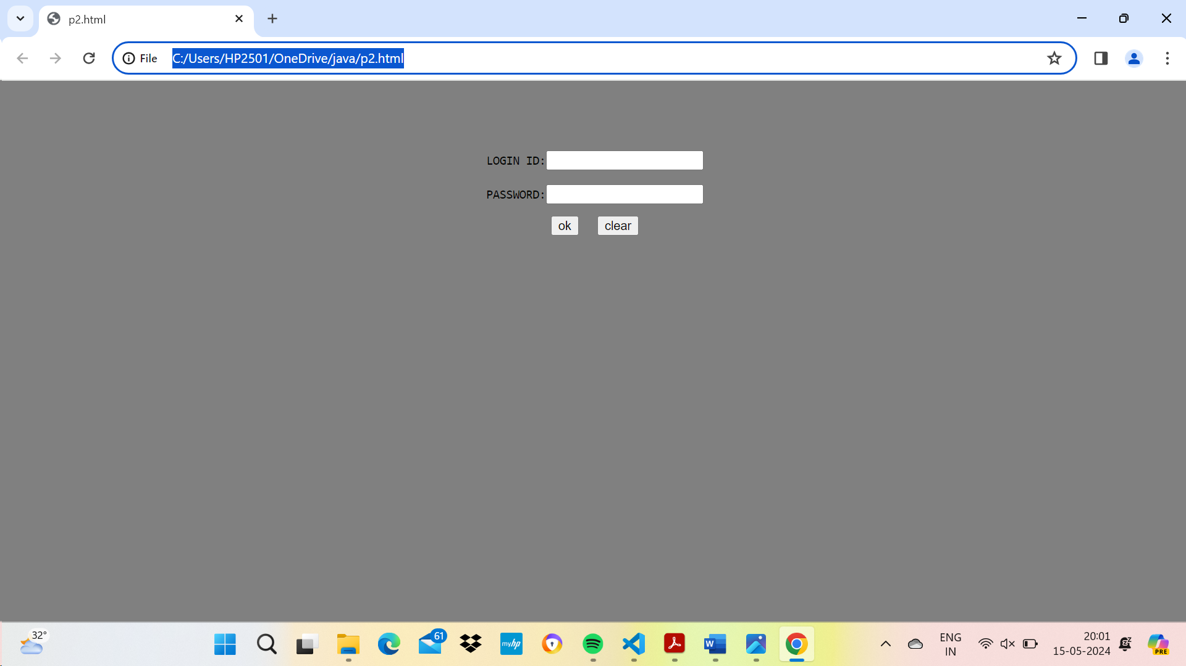

Program 27

<html>

<head>TABLE TAG</head>

<title>TABLE</title>

<body>

<style>

table, th, td

{

border: 1px solid black;

border-collapse:collapse;

padding:15px;

}

#t01

{

background-color: #f1f1c1;

}

td{text-align:center;}

</style>

<table id="t01">

<caption><b>AI&DS ONLINE TABLE</b></caption>

<tr>

<th colspan="4">AI&DS</th>

</tr>

<tr>

<th colspan="4">Monday</th>

</tr>

<tr>

<th>9:30-10:20</th>

<th>10:30-11:20</th>

<th>11:30-12:20</th>

<th>12:30-1:20</th>

</tr>

<tr>

<td>P&S</td>

<td>DS</td>

<td>PY</td>

<td>NM</td>

</tr>

</table>

<hr>

<table id="t02">

<caption><strong>CSE-2 ONLINE TABLE</strong></caption>

<tr>

<th rowspan="4">CSE-2</th>

</tr>

<tr>

<th colspan="4">Monday</th>

</tr>

<tr>

<th>9:30-10:20</th>

<th>10:30-11:20</th>

<th>11:30-12:20</th>

<th>12:30-1:20</th>

</tr>

<tr>

<td>PHY</td>

<td style="background-color: #A52A2A;">DS</td>

<td>P&S</td>

<td>ENG</td>

</tr>

</table>

</body>

</html>

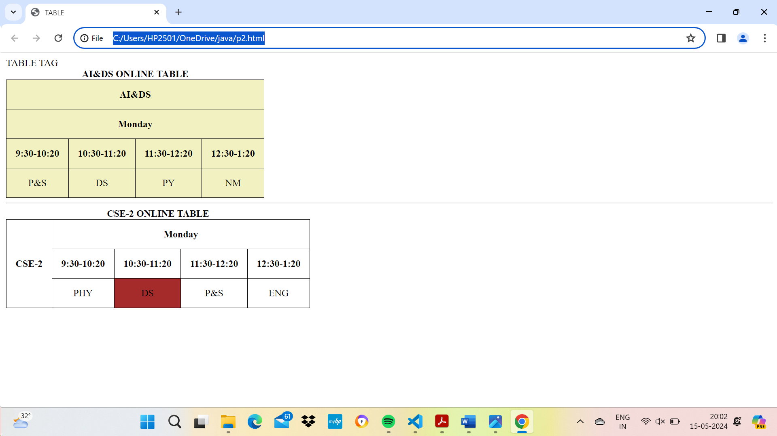

Program 28

<html>

<head>

<title>Get the country capital</title>

<link href="28.css" type="text/css" rel="stylesheet"/>

</head>

<body>

<div class="form-box">

<font color="white" size="4"><b>Select the country name to find its capital and

continent</b></font><br/><br/>

<br>

<select <input type="text" class="resizedTextbox" id="myedit"/>>

<option>Select Country</option>

<option>Germany</option>

<option>United States of America</option>

<option>India</option>

<option>United Kingdom</option>

<option>France</option>

</select>

</div>

<div id="result">&nbsp;</div>

</body>

</html>

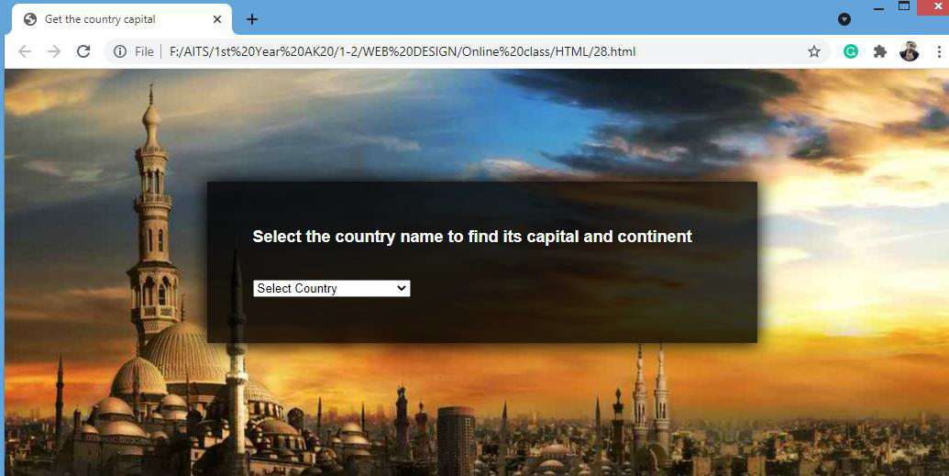

h1{

text-align:center;

}

body{

background:

url(natural.jpeg) no-repeat;

background-position:center center;

font-family:sans-serif;

}

.form-box{

width:500px;

background-color:rgba(0,0,0,0.8);

margin:12% auto;

padding:50px;

color:#fff;

box-shadow:0 0 20px 2px rgba(0,0,0,20);

}

Program 29

<html>

<head><title>Bio Data Form</title>

<style>

h1{text-align:center;

text-decoration: underline}

</style>

</head>

<body>

<h1>Bio Data Form</h1>

<form>

<fieldset>

<legend>Personal:</legend>

<table id="t02" align="center">

<tr><td><label id="name-label" for="name">Name: </label></td>

<td><input autofocus type="text" name="name" id="name" class="input-field"

placeholder="Enter your name" required></td></tr>

<tr><td><label id="fname-label" for="fname">Father's Name: </label></td>

<td><input autofocus type="text" name="fname" id="fname" class="input-field"

placeholder="Enter your father's name" required></td></tr>

<tr><td><label id="mname-label" for="mname">Mother's Name: </label></td>

<td><input autofocus type="text" name="mname" id="mname" class="input-field"

placeholder="Enter your mother's name" required></td></tr>

<tr><td><label id="email-label" for="email">Email: </label></td>

<td><input type="email" name="email" id="email" class="input-field" required

placeholder="Enter your Email"></td></tr>

<tr><td><label id="number-label" for="age">Age: </label></td>

<td><input type="number" name="age" id="number" min="1" max="125" class="inputfield"

placeholder="Age" required></td></tr>

<tr><td><label id="dob-label" for="dob">D.O.B: </label></td>

<td><input type="date" name="dob" id="iddob" class="input-field" required><td></tr>

<tr> <td><label for="department">Department: </label></td>

<td>

<select id="dropdown" name="department" class="dropdown">

<option disabled value>Select an option</option>

<option value="it">IT</option>

<option value="cse">CSE</option>

<option value="ece">ECE</option>

<option value="mech">MECH</option>

<option value="civil">CIVIL</option>

<option value="other">Other</option>

</select></td></tr>

</table>

</fieldset>

<table id="t03" align=center><tr><td>

<label for="gender">Gender: </label>

<ul style="list-style: none;">

<li class="radio"><label><input name="radio-buttons" value="male" type="radio"

class="userRatings" >Male</label></li>

<li class="radio"><label><input name="radio-buttons" value="female" type="radio"

class="userRatings" >Female</label></li>

<li class="radio"><label><input name="radio-buttons" value="others" type="radio"

class="userRatings" >Others</label></li>

</ul>

</td></tr>

<tr><td>

<label for="address">Address: </label></td>

<td><textarea id="comments" class="input-field" style="height:50px;resize:vertical;"

name="address" placeholder="Enter your address here..."></textarea></td></tr>

<tr><td><label for="pincode">Pincode: </label></td>

<td><input type="number" name="pincode" id="idpincode" class="input-field"

style="height:20px;resize:vertical;" placeholder="6 digits Number"></td></tr>

<tr><td><label for="pincode">Phone Number: </label></td>

<td><input type="number" name="Phone Number" id="idphonenumber" class="inputfield"

style="height:20px;resize:vertical;" placeholder="10 digits Number"></td></tr>

<tr><td><label for="language">Language Known: </label>

<ul id="language" style="list-style: none;">

<li class="checkbox"><label><input name="prefer" value="english" type="checkbox"

class="userRatings">English</label></li>

<li class="checkbox"><label><input name="prefer" value="tamil" type="checkbox"

class="userRatings">Tamil</label></li>

<li class="checkbox"><label><input name="prefer" value="hindi" type="checkbox"

class="userRatings">Hindi</label></li>

<li class="checkbox"><label><input name="prefer" value="malayalam"

type="checkbox" class="userRatings">Malayalam</label></li>

<li class="checkbox"><label><input name="prefer" value="kannada" type="checkbox"

class="userRatings">Kannada</label></li>

<li class="checkbox"><label><input name="prefer" value="telugu" type="checkbox"

class="userRatings">Telugu</label></li>

<li class="checkbox"><label><input name="prefer" value="others" type="checkbox"

class="userRatings">Others</label></li>

</ul>

</td></tr>

<tr><td><button id="submit" type="submit">Submit</button></td><td>

<button id="reset" type="reset">Reset</button></td></tr>

</table>

</form>

</body>

</html>

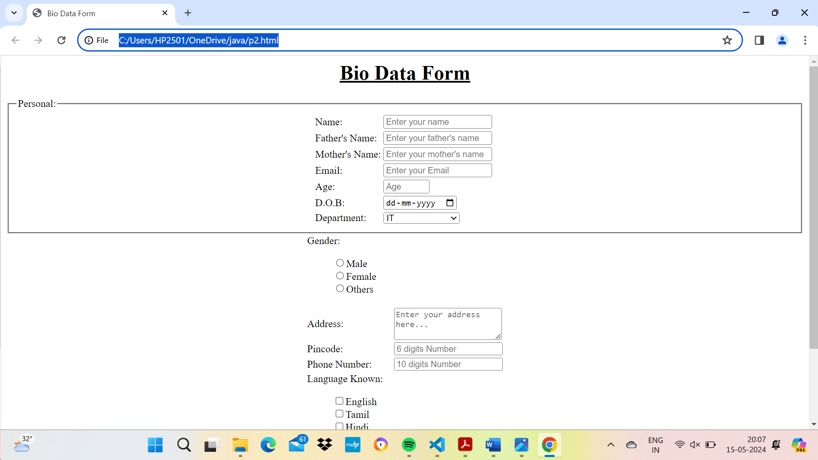

Program 30

<html>

<head><title>Program 30</title></head>

<frameset cols="20%,*,20%">

<frame src="list.html">

<frameset rows="80%,*">

<frame src="picture.html">

<frame src="hyperlink.html">

</frameset>

<frameset cols="*">

<frame src="table.html">

</frameset>

</frameset>

</html>

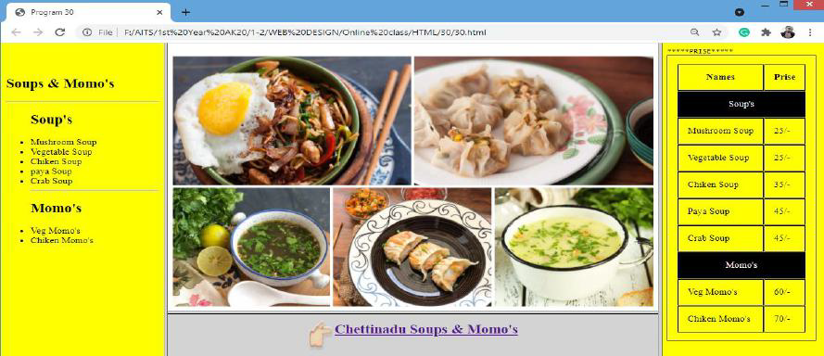

**Save File as list.html**

<html>

<body bgcolor="yellow">

<br>

<br>

<h2>Soups & Momo's</h2>

<hr>

<ul>

<h2>Soup's</h2>

<li>Mushroom Soup</li>

<li>Vegetable Soup</li>

<li>Chiken Soup</li>

<li>paya Soup</li>

<li>Crab Soup</li>

<hr>

<h2>Momo's</h2>

<li>Veg Momo's</li>

<li>Chiken Momo's</li>

</ul>

</body>

</html>

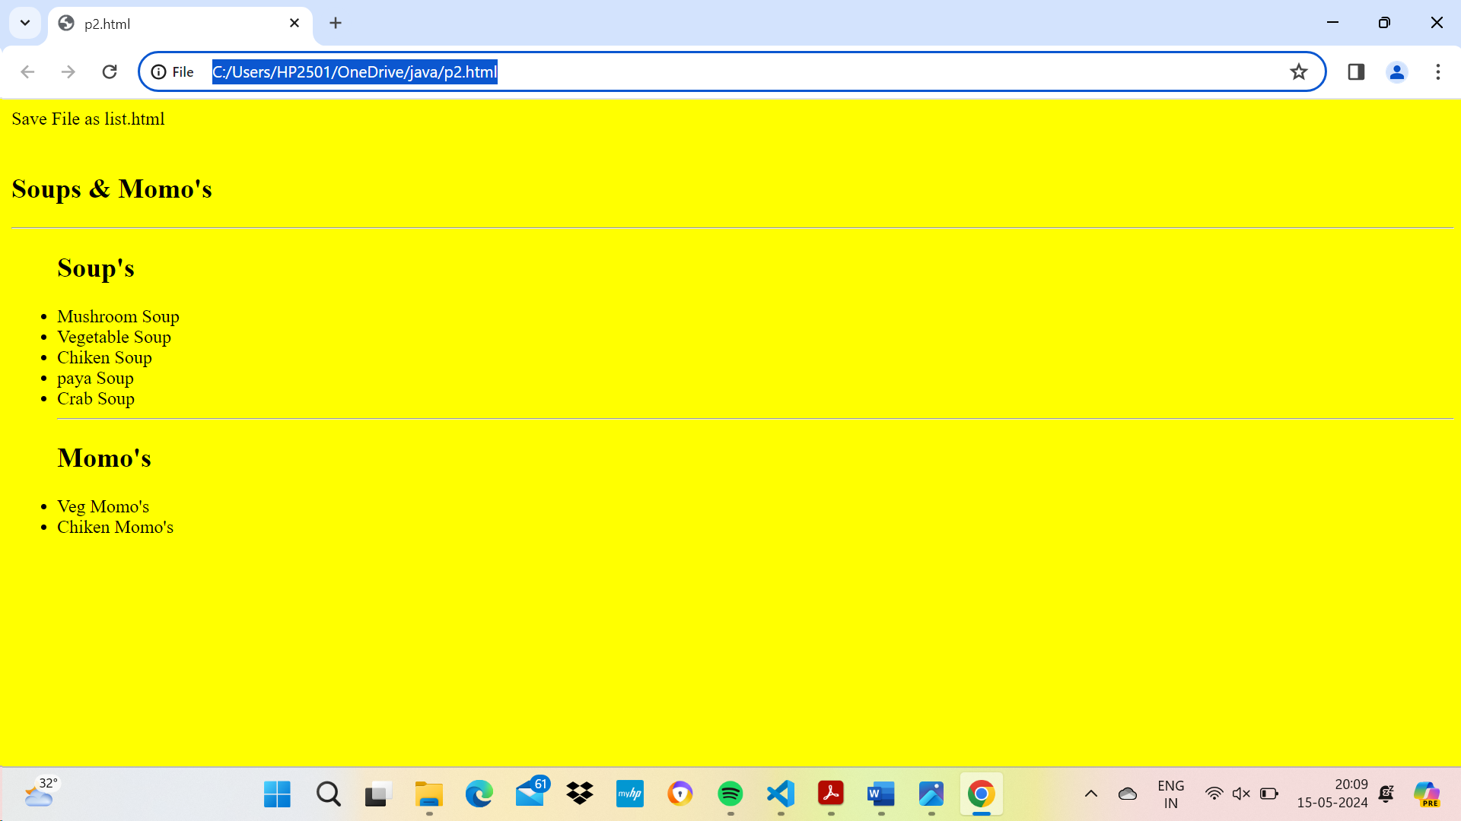

**hyperlink.html**

<html>

<head><title>hyperlink</title>

</head>

<body bgcolor="lightgray">

<table align="center"><tr><td><img src="hand (2).png" height="60px"

width="40px"></td><td><a

href="https://www.google.com/maps/place/Sree+Chettinadu+Soup's+%26+M

omo's/@13.6243684,79.4064922,15z/data=!4m2!3m1!1s0x0:0xa4cf0c90ba7e

380d?sa=X&ved=2ahUKEwiA18f90YDzAhV7zTgGHVFxDDkQ_BJ6BAhcEAU"><h

2>Chettinadu Soups & Momo's</h2></a></td></tr></table>

</body>

</html>

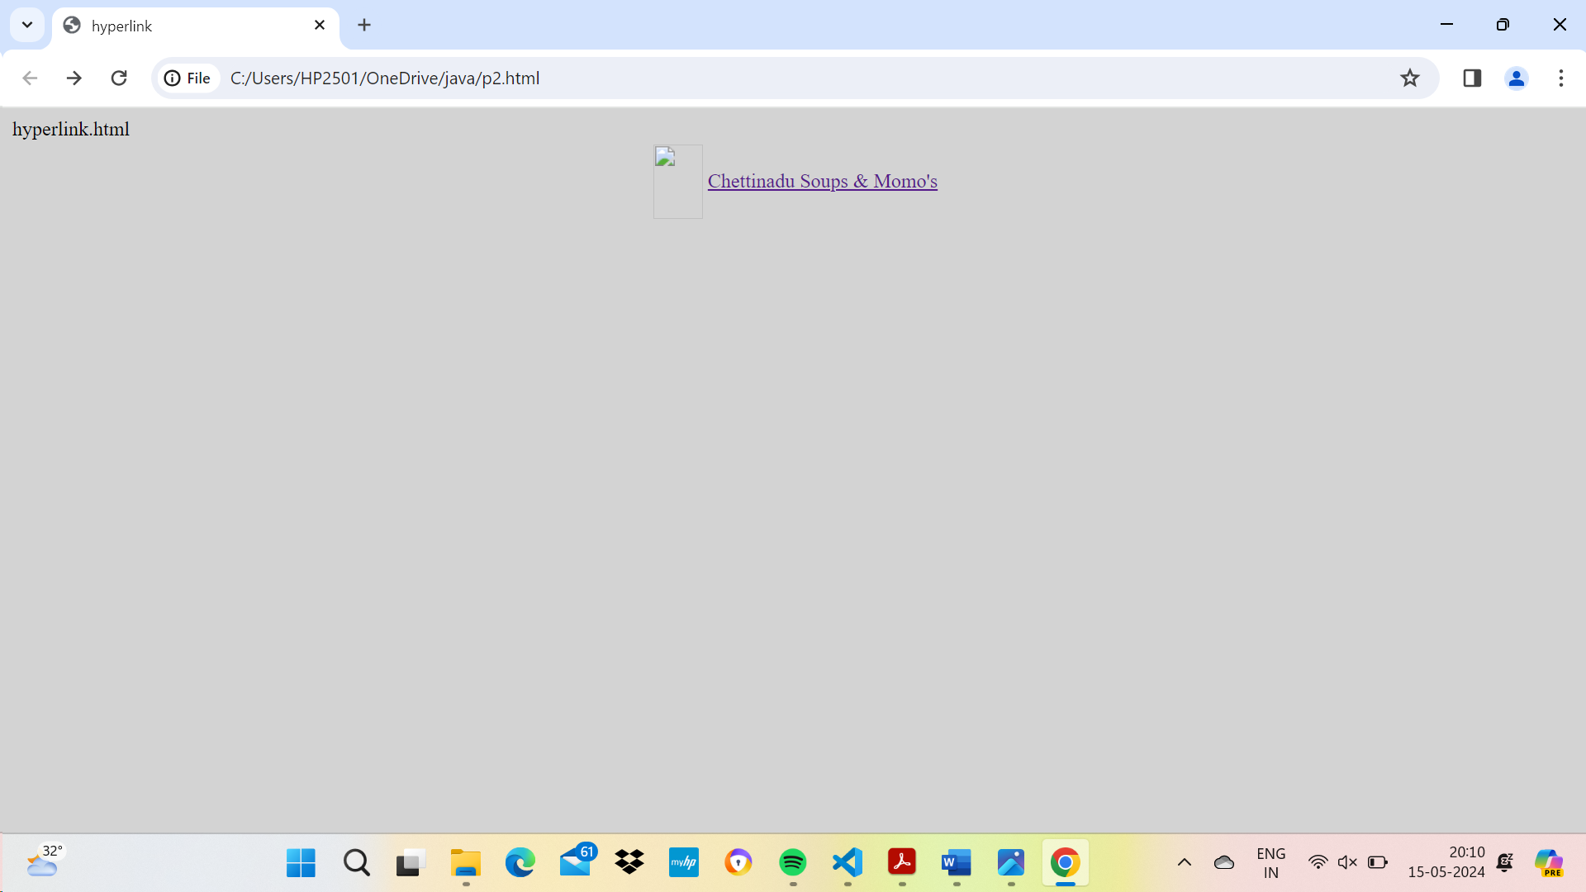

**table.htmt**

<html>

<head><title>Table</title>

<style>

table, th,td{

border:1px solid black;

padding:15px;

}

</style>

</head>

<body bgcolor="yellow">

<table>

<tt>*****PRISE*****</tt>

<tr><th>Names</th><th>Prise</th></tr>

<tr style="color:white;text-align:center;"bgcolor="black"><td

colspan="2">Soup's</td></tr>

<tr><td>Mushroom Soup</td><td>25/-</td></tr>

<tr><td>Vegetable Soup</td><td>25/-</td></tr>

<tr><td>Chiken Soup</td><td>35/-</td></tr>

<tr><td>Paya Soup</td><td>45/-</td></tr>

<tr><td>Crab Soup</td><td>45/-</td></tr>

<tr style="color:white;text-align:center;" bgcolor="black"><td

colspan="2">Momo's</td></tr>

<tr><td>Veg Momo's</td><td>60/-</td></tr>

<tr><td>Chiken Momo's</td><td>70/-</td></tr>

</table>

</body>

</html>

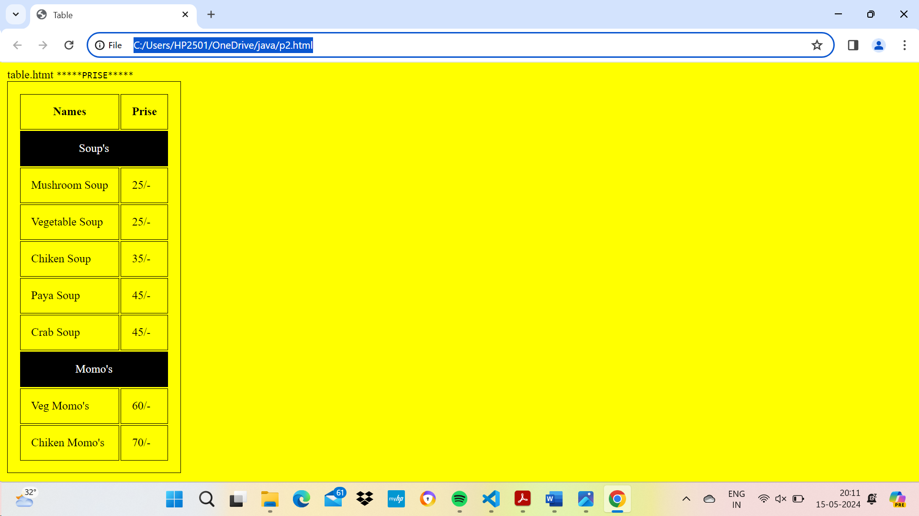

**Save picture.html**

<html>

<body>

<img src="momo_noodles_soup_2018.jpg" width="100%" height="100%">

</body>

</html>

